**Request for Proposal**

Project Name:

Data Project

RFP Ref No:

RFP20221228

**Prepared by:**

FTLife IT

**Document Date:**

28 Dec 2022

**Version:**

1.6

Confidentiality Statement

This document is private and confidential to FTLife Insurance Company Limited and the organization to which it has been addressed. The document and the information contained therein must not be given or communicated to any other parties without explicit written permission of FTLife Insurance Company Limited.

**Table of Contents**

1. Introduction 4

1.1 About FTLife 4

1.2 Objectives 4

1.4 Statement of Work 4

2. Requirements 5

2.1 Business Needs 5

2.1.1 Agency Dashboards 5

2.1.2 Agency Awards Report for Agent 7

2.1.3 Partnership Dashboard 9

2.1.4 Operation Dashboards and Reports 10

2.1.5 Customer Analytics 12

2.1.6 Product Analysis 12

2.2 Enterprise Data Warehouse (EDW) / Data Lake 13

2.3 Architecture & Technical Solutions 14

2.3.1 Data Architecture & Data Flow 14

2.3.2 Data Model 15

2.3.3 Migrate & Sunset Strategy 15

2.3.4 Data governance 16

2.4 Delivery Approach 16

2.4.1 Design & Implementation Phase 16

2.4.2 Post-Implementation Phase 18

2.5 Resource Allocation 18

2.5.1 Data Architecture 18

2.5.2 Implementation 18

2.5.3 On-site / Offshore Ratio 19

2.5.4 Team structure for project phase & BAU phase 19

2.6 Data Security 19

2.7 Service Level and Incident Management 20

2.8 Project Governance Structure 20

3. Evaluation / Selection Approach 21

4. Response Format & Guidelines 22

4.1 Response Requirements 22

4.2 Additional Information 22

4.3 Timeline 23

4.4 Format & Return of RFP Response to FTLife 23

5. Written Response 23

5.1 Vendor Information 23

5.1.1 Contact Details 23

5.1.2 Size & Operating Performance 25

5.1.3 Current Projects and Resourcing 26

5.1.4 Contract Sample 26

5.1.5 Project Reference 26

5.2 Proposed Solution 27

5.2.1 Reference Sites 27

5.2.2 Technical Proposal Section 28

5.2.3 Financial Proposal Section 29

5.2.4 Demonstrations / Presentations 29

5.2.5 Sample Documents / Outputs 29

5.2.6 Implementation Approach 29

6. Appendix 30

6.1 AAP report List 30

6.2 Application list in used for FTLife 37

6.3 Service Request (SR) Ticket Examples 39

7. Confidentiality Statement 45

# 1. Introduction

## 1.1 About FTLife

FTLife Insurance Company Limited ("FTLife") has been a wholly-owned subsidiary of NWS Holdings Limited since 2019. This is a signiﬁcant milestone for us as it marks the start of a new era under the umbrella of New World Group.

We have more than 30 years of heritage in providing individuals and institutions with diversiﬁed insurance and ﬁnancial planning products and services, including life, health, accident, savings and investment insurance. As a member of New World Group, we work with diversiﬁed businesses within the Group to create synergies and provide our customers with best-in-class life-planning solutions, from wealth management and succession to health, well-being and quality of life enhancement, that help them lead more fulﬁlling lives.

It is a golden era full of opportunities. We will leverage the diverse businesses and great business network of the Group to work side-by-side with different stakeholders as we strive for continuous innovation and success.

## 1.2 Objectives

FTLife is requesting proposals from qualified service providers to engage in our data initiative to design and implement the target data platform included the key components listed below:

1. Enterprise data warehouse (EDW) / data lake with well-defined data marts for per-defined and self-service/end-user reporting
2. Operational data store (ODS) as source of truth for channels’ applications
3. Customer 360 / Single View of Customer data store (SVOC) as source of truth for customers’ related demographic, interaction, transaction and behaviour data based on single customer identity
4. Data synchronization and ingestion flows from source to EDW, ODS and SVOC in prioritization of real-time, mini-batch, batch based on nature of data

The target data platform shall apply standard data model in ODS, appropriate data governance to fulfil our growing business needs. It should have the capability to be further expanded for future data analytics and machine learning for trend prediction and discover new business opportunities from data.

This RFP lists the requirements of service and deliveries in Section 2, and the process and timeline of proposal submission and evaluation in Sections 3. This document is issued for information and planning purposes and does not commit FTLife to contract for any service or deliveries. FTLife will not reimburse any costs incurred as a result of participation in response to the RFP.

The total value of the proposal should not include the cost of infrastructure, cloud subscriptions and tools (i.e. software or license subscription).

## 1.4 Statement of Work

The statement of work will cover the followings topics, and details should be referred to Section 2 of this RFP.

**Part 1: Business needs, Data architecture design & implementation**

1. **Current and future Business needs ride on new EDW/ data lake platform, data ingestion/servicing approaches**:
   1. **Existing Analytics/Reporting Requirements:** Fulfil identified business needs including but not limit to agency and partnership sales, agency awards, persistency, indicators of identifying high risk agents, claims, product sales and analysis and customer analytics
   2. **Foundation for advance analytics:** The data platform foundation shall enable the implementation of advanced analytics use case included but not limited to stream analytics, facilitate ML OPS in the future
2. **Current and future Business needs ride on new Operational Data Store, Single Customer View Data Store with standard data model as the source of truth for channels’ consumption**
   1. **Existing Real-time data services requirements:** Fulfil identified inquiry services such as policy, customer level enquiry from agency (B2A) / brokers (B2B), customer (B2C) and internal (B2E) channels
   2. **Foundation for real-time event consumption:** Fulfil the consumption of data events (such as customer’s birthday reminder, policy payment due date reminder)in real-time basis from omni channels with event driven architecture
3. **Architecture**: Suggest architecture design and data flow of data platform including EDW / data lake, Operational Data Store, Customer 360 Data Store for insurance. Design and implement the data platform (hybrid approach of On-Premise and cloud) including data model, data ingestion, ETL, Change Data Capture (CDC), data transformation, data analytics, data servicing/consumption and visualization dashboards.

**Part 2: Data governance**

1. **Governance approach**: Propose a data governance approach that can operationalize the workflow & process to deliver both sensitive and non-sensitive data with approvals for various audiences across the organization.
2. **Data glossary and dictionary**: Define data terminology to standardize the language across the organization.
3. **Risks**: Ensure compliance and mitigate risks

**Part 3: New World eco system**

The target data platform shall be able to exchange data with our group, New World to discover the cross-sell potential, lead generation as well as other initiatives to provide value-added services to existing and potential customers

**Part 4: Target Operation Model (TOM)**

1. Propose and set up TOM of project phase
2. Suggest a transition method from the project TOM to ongoing running (i.e., BAU) phase

**Part 5: Delivery approach**

1. Delivery approach should be in Agile way of working and there shall be focus in delivering an initial MVP and beyond.
2. Scope is suggested by phase together with the delivery approach and target sunset systems.

# 2. Requirements

## 2.1 Business Needs

Data Services enablement with 7x24 Operational Data Store

The service provider shall design and implement Operational Data Store (ODS) as source of truth for Agency, Broker, Customer and internal channels’ applications to inquiry policy, agent, customer, claim level data via various means (e.g., APIs). Standard data model shall be applied in ODS and data shall be synchronized from difference source systems (e.g. Core System) in real-time or near real-time manner

Customer Centricity with Customer 360 View Data Store

The service provide shall design and implement Customer 360 View Data Store as part of the target data platform which provides a customer (or potential customers) centric view on their demographic, transaction, behavior and interaction data. This shall be aligned with New World eco system’s One CRM Strategy

Reporting & Analytics

The service provider shall help to discover business needs from existing reports, reviewing existing code or interviewing business user during project phase. The business needs include but not limit to agency and partnership sales, agency awards, persistency, indicators of identifying high risk agents, claims, product sales and analysis and customer analytics.

### 2.1.1 Reports/Dashboards Requirements

#### 2.1.1.1 Agency Dashboards

Agency Performance Dashboards have been developing by existing data warehouse in FTLife. The service provider is required to develop dashboards on new created EDW / data lake based on new data model. The following shows the list of existing dashboards (For reference only – subject to change during actual implementation phase).

| **#** | **Dashboard Name** | **Examples** |
| --- | --- | --- |
| 1 | Overall performance of Agency | By region, district, unit and agent level,   * MTD and YTD manpower * MTD and YTD APE submitted and approved * MTD and YTD case submitted and approved * MTD and YTD AFYC submitted and approved * VoNB * AFYC/Case/APE growth% (YTD) * Persistency (both L19 and L25) * Zone 1 and Zone 2 * CYTD Issued * LYYTD Issued * Issued Growth % * CYTD Submitted * LYYTD Submitted * Submitted Growth % * CYTD Issued Case * LYYTD Issued Case * Issued Case Growth % * CYTD Submitted Case * LYYTD Submitted Case * Submitted Case Growth % |
| 2 | Sales Growth vs MP Growth |
| 3 | Sales Trend comparing with previous year |
| 4 | Manpower Trend |
| 5 | Scorecard Overview |
| 6 | Sales Growth Scorecard |
| 7 | Quota Fulfillment Scorecard |
| 8 | Org-Recruit Per Manager Scorecard |
| 9 | Business Quality Scorecard |
| 10 | Effective Agent Ratio Scorecard |
| 11 | Inforce Region – Sales Performance |
| 12 | Manpower, Active % and Productivity |
| 13 | Product Mix |
| 14 | Inforce Unit Productivity |
| 15 | Agency Performance Segmentation |
| 16 | Agency Performance (Personal) |
| 17 | AFYC Persistency - Agent |
| 18 | Recruitment |

**Example of Agency Performance Dashboard**

|  |  |  |  |  |
| --- | --- | --- | --- | --- |
|  | Agency Performance | | | |
|  | Last Single Day | MTD,  Last Year MTD,  Last Year Month end | YTD,  Last Year YTD,  Last Year End | Growth % |
| Submitted Case |  |  |  |  |
| Submitted AFYC |  |  |  |  |
| Submitted APE |  |  |  |  |
| Approved Case |  |  |  |  |
| Approved AFYC |  |  |  |  |
| Approved APE |  |  |  |  |

**Example of Persistency calculation**

|  |  |  |  |  |
| --- | --- | --- | --- | --- |
| **LIMRA 19/25** | **Agent Level   (Agent, AM and above)** | **Manager Level   (AM and above)** | **Region Level** | **Agency Total** |
| NO Orphan | Use Agent/Manager’ PERSONAL  Persistency in WCM020B (for Limra 19) and  WCM020C (for Limra 25) | Use Manager’s  UNIT  Persistency % in  WCM020B (for Limra 19) and  WCM020C (for Limra 25) | Use RD’s  DOWN_LINE  Persistency in  WCM020B (for Limra 19) and  WCM020C (for Limra 25) | **By assumption**, use Inforce Agent’s PERSONAL  [Total Lapse] and [Total Exposure] in eBao to calculate the Without Orphan Persistency for Total Agency |
| WITH Orphan | Not applicable for Agent Level | **By assumption**, use the data as in the ^ Actuarial report to calculate UNIT Persistency with similar logic as for the Region Level | Use data and logic as in the ^ Actuarial report | Use the data and logic in the ^Actuarial report |

| **#** | **Items** | **Definition** |
| --- | --- | --- |
| 1 | APE (HK$ 'M) | Sum of MTD APE Approved |
| 2 | Agent Productivity by APE | Sum of MTD APE Approved, divided by average of MTD Manpower |
| 3 | Case Size by APE | Sum of MTD APE Approved, divided by sum of MTD Approval Case Count |
| 4 | Average Case (Per Agent) | Sum of MTD Approval Case Count, divided by average of MTD Manpower *~ MTD Manpower = 1 for Agent with [Agent Status] = "Inforce"* *in that month* |
| 5 | Case per Active Agent | Sum of MTD Approval Case Count, divided by average of MTD Inforce Active Agent Count *~ Active Agent Count = 1 for Agent with [Agent Status] = "Inforce" and [MTD Approval Case Count] >= 1 in that month* |
| 6 | Activity Ratio  - New Agents  - Existing Agents | # of Inforce Active Agent, dividied by # of Agent *~ Active Agent Count = 1 for Agent with [Agent Status] = "Inforce" and [MTD Approval Case Count] >= 1 in that month ~ New Agents = those Contract_Effective_Date fall in immediate last 12 months* |
| 7 | Gross Recruit | Total number of Agent with Contract_Effectve_Date fall in the measuring period |
| 8 | MDRT | No. of Inforce Agents in the "MDRT" report whose [Awards] not equal to Blank (as of the Calendar Year measuring period end) |
| 9 | Star Force | No. of Inforce Agent whose [YTD Approval Gross AFYC] >=100,000 (as of the Calendar Year measuring period end), excluding those with [Awards] in "MDRT" is not equal to Blank |
| 10 | Active Leader % in Recruitment | No. of Inforce Manager (AM and above) who have at least 1 gross new recruit in YTD (as of the Calendar Year measuring period end) |
| 11 | POS Usage | # of policy issued submitted via POS, divided by total number of policy submitted (which is available to submitted via POS) |
| 12 | LIMRA 19 AFYP Persistency  with Orphan | The AFYP Persistency of LIMRA 19 month as of current month |

#### 2.1.1.2 Agency Awards Report for Agent

Agency Annual Awards (AAP) reports are the existing reports in FTLife using Self-Developed (SD) scripts to generate. The service provider can use the SD reports as a reference or develop the dashboard based on the SD reports’ results. However, the new AAP reports should be 100% relied on new EDW / data lake standard to build. After the AAP is go-live, the existing SD scripts would be sunset. The following categories are the examples of the AAP reports - Full list (Some report fields are provided for reference) is shown in **Appendix**.

| **Report Category** | **Example(s)** |
| --- | --- |
| Regional Agent Performance | For Executive-level Regional Director / Regional Director   * Highest Commission in the team (First Year) * Highest Commission in the team by Region * Highest Productivity * Highest Growth |
| Region Performance | * 10 Million Region * Most MDRT Region * Most MDRT Leader |
| District Agent Performance | For District Director / Senior Manager / Senior Agency Manager   * Highest Commission in the team (First Year)   Highest Productivity   * Highest Growth |
| Recruitment | * Highest number of Recruitment * Best Recruitment agent * LEAP & Beyond Best District Recruitment * LEAP & Beyond Best Manager Recruitment |
| Individual Performance | * Achiever of the Year * Achiever Club * Case Achiever of the Year * Health Case Achiever of the Year * Cases Club * Rookie of the Year * Rookie Club * Long Service Awards (5,10, 15, 20 Years) * Loyalty Awards * CMF Individual Award * etc |

Example of existing report “Highest Commission in the team (First Year)” is shown as below. The service provider can refer to the result to design the data model & dashboard/report (The final result is subject to change and finalize when the actual implementation is started).

Example 1 – A1.2

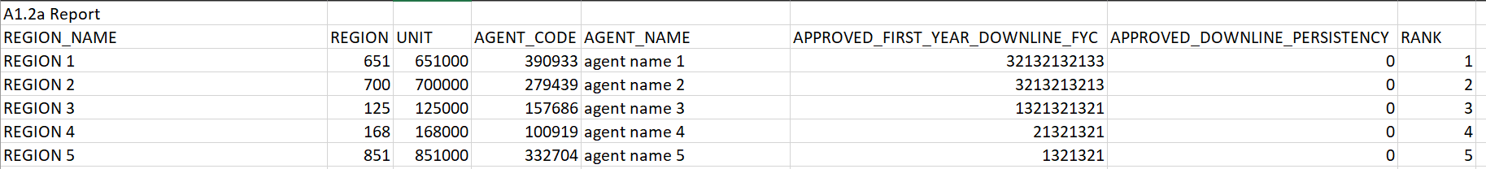

Example 2

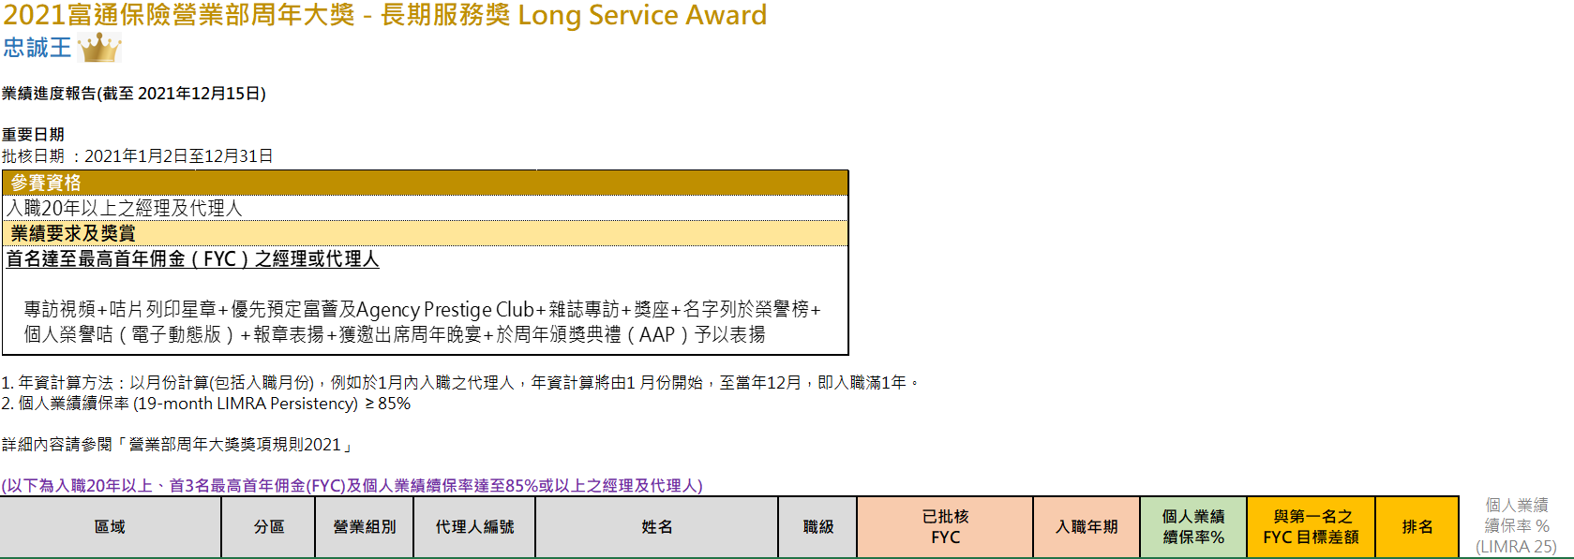

Example 3

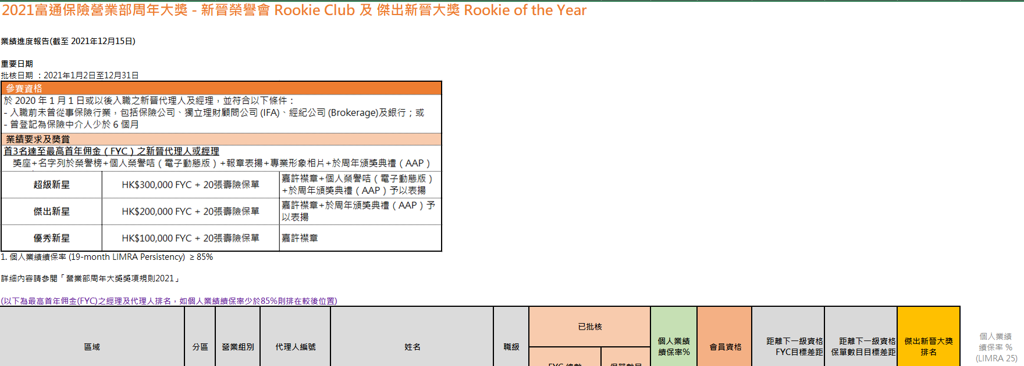

Example 4

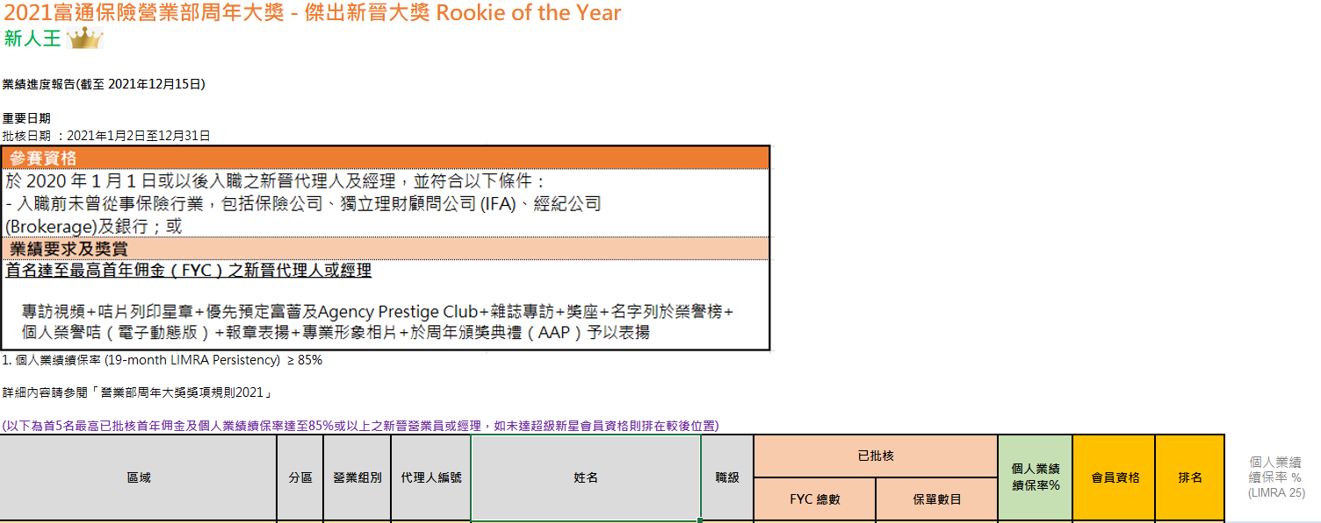

Example 5

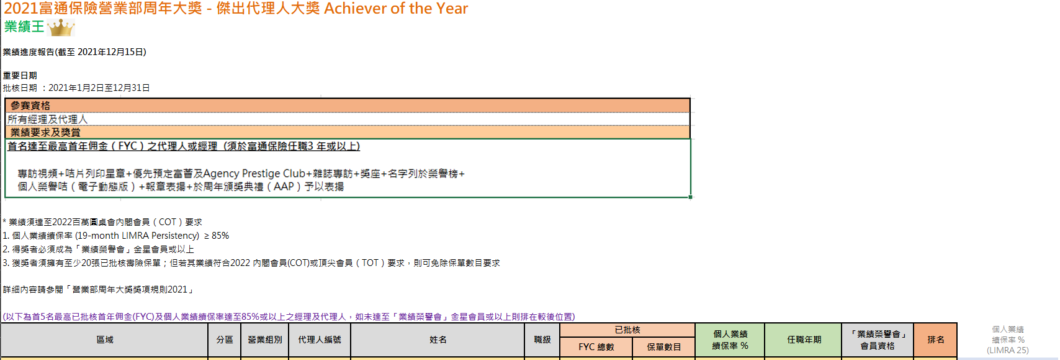

#### 2.1.1.3 Partnership Dashboard

Existing Partnership Performance Dashboard has been built in Qlik Sense. The service provider is required to develop the dashboard in EDW / data lake based on the defined data model. The following shows the list of existing dashboards (For reference only – subject to change during the implementation phase).

1. Partnership Dashboard Overall
2. Partnership Sales Manager Dashboards x 8 for different sales manager

Examples for reference of the Partnership Executive Dashboard (masked) are shown as below,

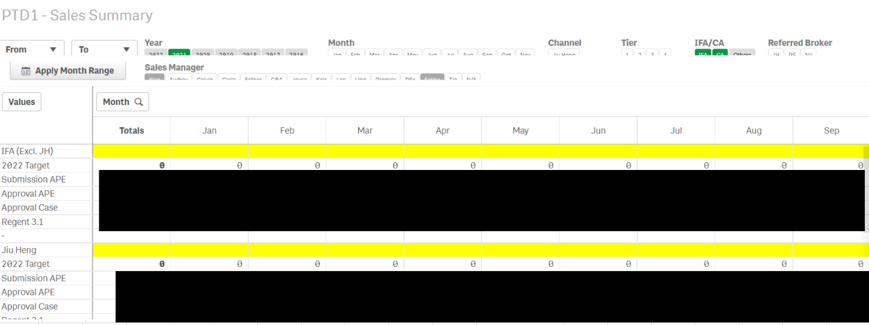

The service provider needs to also show the migration plan of the existing dashboards/reports to EDW so that the dashboards/reports on Qlik Sense can be sunset.

#### 2.1.1.4 Operation Dashboards and Reports

Service provider shall propose claims dashboard based on past experiences that can benefit most the insurance business/operation.

##### 2.1.1.4.1 Service Request for Operation

Regular service request (SR) from operation department is one of the critical item that needs to be addressed. The following shows some examples of those requests,

1. Extract the policy information for those trust policies
2. Obtain the policy listing of cases settlement for the reporting period, i.e. 01 Oct 2019 to 31 Dec 2
3. Extract data for the fund corporate action of specified code (e.g., F151, F144)
4. Extract CAI claims data (format with product = CAI)
5. 腸胃鏡手術 data in 2019, 2020, 2021, 2022
6. Extract 2 non-payment levy policy lists
7. Exceptional report for fast approve case
8. Data extraction for specific product HC168 and HC168II
9. Extract data fields “Termination Date” and “Policy Status” from eBao
10. Extract data from the customer database which matched the full World-Check Records up to 20 M
11. Extract claim data in the attachment format for all medical product starting from 2020

##### 2.1.1.4.2 New Business (NB) and Claims

Another requirement is the claims lost ratio, NB Pending and claims turn around time (TAT).

**Example of NB pending**

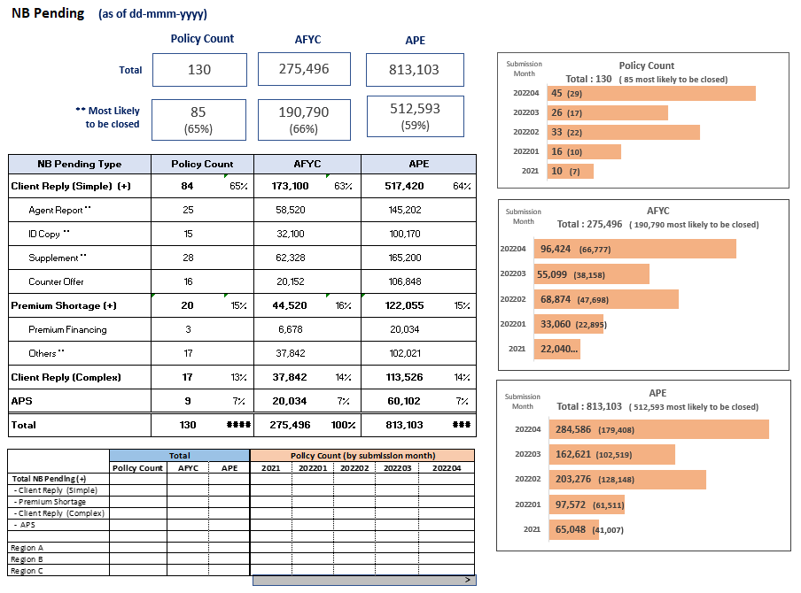

|  |  |  |
| --- | --- | --- |
| **#** | **Items** | **Definition** |
| 1.1 | Tota Policy Count | Sum of Policy Count / AFYC / APE of all policy submitted by Agency Channel that are currently at pending stage **(~ NB pending policies)** |
| 1.2 | Total AFYC |
| 1.3 | Total APE |
| 1.3 | NB Pending Type | Total 4 types a. Client Reply (Simple)  - e.g. supplementary form declaration,  agent’s report, ID copies, acceptance of   counter offer letter etc. b. Premium Shortage  - underwriting completed c. Client Reply (Complete)  - e.g. need further financial / medical /  AML assessment etc. d. APS  ( Attending Physician Statement?)  ~ e.g. medical report |
| 1.4 | Most Likely to be closed (of Total | Sum of Policy count / AFYC / APE of NB pending policies, which NB Pending Sub Type =   1. ID Copy  2. Agent Report  3. Supplement - Others  4. Counter Offer for Loading/Exclusion/Others |

Example of claims TAT

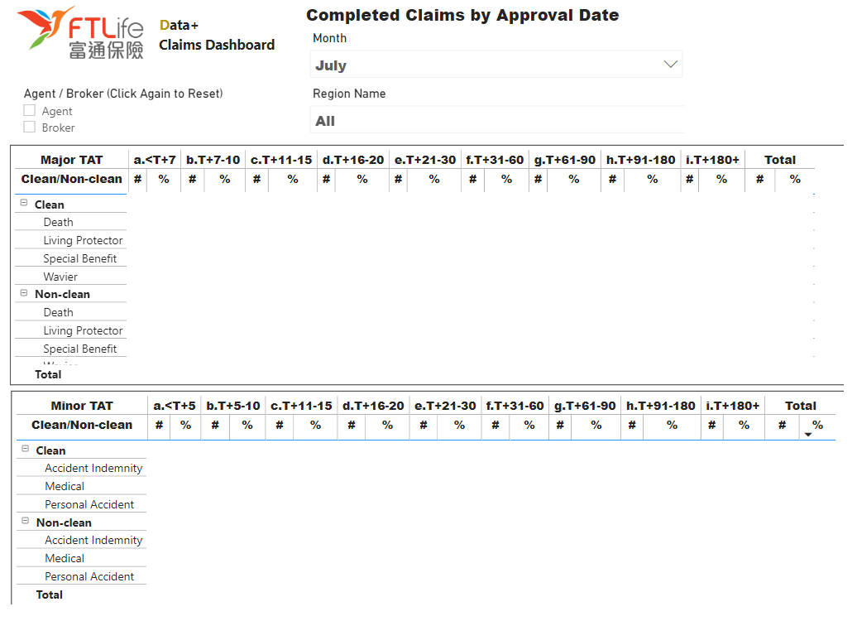

#### 2.1.1.5 Customer Analytics

Our business requires to have the following data to enable an important function “Customer Data” to provide offers or campaigns to customers. All the data should come from core system (eBao). Service Provider needs to fit in the below requirements as much as possible into the data model design.

|  |  |
| --- | --- |
| **Category** | **Field Examples** |
| Single Customer View | Policy Holder, APE, Premium Term, Plan Code etc |
| Agent Profile | Agent Code, Agent Name, Agent DoB etc |
| Agent Productivity | Agent Persistency, Active Ratio etc |
| Policy Holder Beneficiary | Relation ID, Relation Desc, Service Agent etc |
| Policy Holder Insured | Insured ID, Relation ID, Relation Desc, Service Agent etc |
| Claims | Case No, registration Time, Policy Holder, Liability Name, Claim Status etc |
| Budget | Channel, YYYYMM, APE Budget, VoNB Budget |

#### 2.1.1.6 Product Analysis

The service provider needs to help to implement the product analysis dashboard for FTLife Product department. The following list some of the existing in-used reports (but not limit to) for product team.

SBD0058 Unit Link Fund Portfolio Accum Report (AGTB)SBD0059 Unit Link Fund Portfolio Accum Report (IFAC)SBD0072 Unit Link Top 10 Fund Movement ReportSBD0073 NAV Report - Fund LevelSBD0074 Unit Link Fund Portfolio Accum Report (IFAC Details)SBD0077 Unit Link Top 5 Fund Movement Report - Fund House LevelSBD0078 Unit Link Top 10 Fund Movement Report - Fund Category LevelSBD0079 NAV Report - Fund House LevelSBD0080 NAV Report - Channel LevelSBD0081 Unit Link Hottest Fund Per Fund House ReportSBD0082 Unit Link Fund Movement - Fund Level Report (MTD)SBD0083 Unit Link Fund Movement - Fund Level Report (YTD)SBD0084 Unit Link Fund Movement - Fund Level (with Cash and Switch Flow) Report (MTD)SBD0085 Unit Link Fund Movement - Fund Level (with Cash and Switch Flow) Report (YTD)SBD0086 Unit Link Fund Movement Report - Fund House LevelSBD0087 Unit Link Fund Movement Report - Fund Category LevelSBD0091 Unit Link Fund Movement - Fund Level (with Cash and Switch Flow) Report (Daily Accum)SBD0092 Unit Link Fund Movement - Fund Level (with Cash and Switch Flow) Report (Daily)SBD0093 Unit Link Fund House Movement - Fund Level (with Cash and Switch Flow) Report (Daily Accum)SBD0094 Unit Link Fund House Movement - Fund Level (with Cash and Switch Flow) Report (Daily)SBD0095 Unit Link Fund House Movement - Fund Level (with Cash and Switch Flow) Report (MTD)SBD0096 Unit Link Fund House Movement - Fund Level (with Cash and Switch Flow) Report (YTD)SBD0101 RMB Submission Report - Policy LevelSBD0102 RMB Submission Report - Agent LevelSBD0103 RMB Submission Report - Region LevelSBD0104 RMB Submission Report - Region Level for ADSBD0105 CIFH2SubmissionReportRegionSBD0107 CIESSaleReportSBD0108 UWAPSubmissionReportSBD0109 IEliteClubIssueDetailReportSBD0110 IEliteClubIssueSummaryReportSBD0111 IEliteClubSubmissionDetailReportSBD0112 IEliteClubSubmissionSummaryReportSBD0113 CheersSubmissionReportSBD0114 CheersSubmissionReport_no_PPPSBD0115 CheersConversionSalesReportSBD0116 CheersNormalSalesReportSBD0117 LifeConversionDetailReportSBD0118 Cheers_SUWP_WkSalesRptSBD0119 MediConvCamp_WklySumSRSBD0120 MediConvCamp_MZA10_CheersSRSBD0121 MediConvCamp_OthersSRSBD0122 RMB2SubmissionReportSBD0123 MediConvCamp_WklySumSR_DistrictSBD0124 CheersConversionSalesReport_DistrictSBD0125 UWAP Campaign Sale ReportSBD0126 Elite Choice Weekly Currency ReportSBD0126 Elite Choice Weekly Currency ReportSBD0128 Life Conversion Detail Report 2013SBD0129 Life Conversion Summary Report 2013SBD0130 Fortune 100 Submission ReportSBD0131 Weekly Product Mix ReportSBD0132 Monthly Product Mix ReportSBD0133 Weekly Product Mix Report For IFASBD0134 Monthly Product Mix Report For IFASBD0135 Weekly Agency Product Mix Report For Preferred ProductsSBD0136 IFA Monthly Issue Product Mix ReportSBD0137 Campaign Product Production ReportSBD0138 SPSL Weekly Sales ReportSBD0139 New CI Solution Sales Report

### 2.1.2 Real-time Data Services – Data Enablement Requirements

#### 2.1.2.1 Inquiry Data APIs for channels ride on new Operational Data Store & new Customer 360 Data Store

The service provider is required to implement 5 basic Inquiry Data APIs set based on the newly implemented Operational Data Store with standard data model defined during the project:

1. Application Level
   1. Inquiry application list (single record or list by parameter/s)
   2. Inquiry application detail by policy #
2. Policy Level
   1. Inquiry policy header/summary (single record or list by parameter/s)
   2. Inquiry policy detail by policy #
   3. Inquiry policy beneficiary by policy #
   4. Inquiry fund value detail by policy #
3. Agent Level
   1. Inquiry agent profile by agent code
   2. Inquiry agent hierarchy by agent code
   3. Inquiry compensation detail by agent code + date range
   4. Inquiry performance detail by agent code + date range
4. Customer Level
   1. Inquiry customer summary (single record or list by parameter/s)
   2. Inquiry customer detail by customer ID
5. Claim Level
   1. Inquiry claims summary (single record or list by parameter/s)
   2. Inquiry claim detail by claim #

There are existing APIs implemented for above functions currently used by different channels, it is expected migration roadmap based on existing channels’ technology refreshment shall be defined with FTLife’s team to convergence these APIs with the new set of APIs after this project

#### 2.1.2.2 Implement real-time data synchronization to refresh data in Operational Data Store & Customer 360 Data Store

The service provider is required to implement real-time data synchronization flows from source systems to new Operational Data Store (ODS) & Customer 360 Data Store

#### 2.1.2.3 Implement real-time/near real-time data synchronization to refresh data from Operational Data Store & Customer 360 Data Store to CRM

SFMC (Salesforce Marketing Cloud) currently require (1) policy + benefit, (2) customer, (3) agent level data to operate. The service provider is required to implement real-time/near real-time data synchronization flows from new Operational Data Store (ODS) and new Customer 360 Data Store to Salesforce

## 2.2 Operational Data Store & Customer 360 Data Store

The service provider is required to design, develop & implement Operational Data Store (ODS) and Customer 360 Data Store. It is expected that ODS & Customer 360 Data Store may or may not be part of Data Lake Solutions depends on final architecture design proposed with rationale. The following characteristics are expected for ODS and Customer 360 Data Store:

1. ODS & Customer 360 Data Store shall apply the standardized insurance domain data model defined along with the target data platform
2. ODS shall be the source of truth of operational data, i.e., data readiness of ODS shall be same as underlying source systems which imply that real-time data synchronization is required to establish from source systems to ODS
3. As a standardized data layer of source of truth, ODS is intended to replace the various data synchronization from core system to channel applications, so ODS shall target to enable necessary data to fulfil functional need of all channel applications
4. ODS shall be “read-only” from channels’ perspective, i.e., it shall enable only inquiry APIs (as described in section 2.1.2.1) to serve multiple channels for their operational need
5. Customer 360 Data Store shall be positioned as source of truth for key attributes of customer’s demographic, transactions, behavior and interaction data. It does not contain full set of these data but shall have mechanism to link up these data from the source system of corresponding data (e.g., interaction data from CRM, transaction data from ODS etc.)
6. Customer 360 Data Store shall be part of the customer onboarding process (e.g., from POS during NB application) to register the single customer identity along with FTLife’s business defined customer identification attributes

**List of Data sources for ODS & Customer 360 Data Store**

| **System** | **Category** |
| --- | --- |
| eBao | eBao Life - U/W eBao - Agency eBao Life - Claims eBao Life - Valuation eBao Life - Finance eBao Life - Policy Administration eBao Life – Product |
| POS | POS – Mobile Application – NB Application Digital Direct – B2C Self-Service Application – NB Application |

## 2.3 Enterprise Data Warehouse (EDW) / Data Lake

The service provider is required to design, develop & implement EDW /data lake by hybrid Cloud and On-premise solution. The data sources of EDW /data lake should come from existing systems in FTLife such as core system (eBao), POS sales system and P-series systems. It should also support the data sources that are in undefined format from user tailor made files (i.e., CSV). EDW should be the single source of truth for reporting and analytics needs for the entire FTLife company.

The following table shows the potential data sources from FTLife.

**List of Data sources\***

| **System** | **Category** |
| --- | --- |
| eBao | eBao Life - U/W eBao - Agency eBao Life - Claims eBao Life - Valuation eBao Life - Finance eBao Life - Policy Administration eBao Life – Product |
| POS | POS Mobile Application |
| P-series | Customer Service App (P10)  Salesforce (P14)  Electronic New Business Application Center (P02)  Payment Platform (P05)  Customer Service Center (P03)  Management Performance Dashboard (P06)  Sales Management System (P06)  Agency Campaign (P06)  Mobile Business Development App (P08/P09) |
| CSM | CSM System (Siebel) |
| BOSS | BOSS - Agent Portal BOSS - Financial Express BOSS - IFA / CA Portal BOSS - Customer Portal |
| Data Feed | DataFeed for Partnership |

Expected Outcome after implementing the EDW/data lake,

* Single Source of Truth for various analytics functions, e.g., data store – historical data until now for self-service or automated reporting/dashboard, advanced analytics with AI/ML
* Well-define domain specified data marts (e.g., New Business, Agency, Broker, Claim, Finance … etc.) for various report/dashboard requirements for corresponding business units
* Elimination of various data synchronizations currently for reporting requirements
* Standardize the methodology of data ingestion incl.:
  + Real-time data ingestion
  + Near real-time mini batch data ingestion (e.g., in minutes schedule)
  + Batch data ingestion (only for source systems not capable to adopt real-time/near real-time data ingestion in nearby 2 years)
* Automation to eliminate manual data extraction
* Enable efficient data analysis and data science
* Accessible to other applications by API
* Self-service capability
* Gradually sunset existing MIS/SD Report

## 2.4 Architecture & Technical Solutions

The Service Provider is required to provide overall EDW / data lake solution, data architecture, data model design, data flow, integration design & ETL design and dashboards & report design.

### 2.4.1 Data Architecture & Data Flow

FTLife is looking for a high reusable, extensible data platform with below features:

1. Design for long-term Roadmap and short-term delivery & Implementation with future prove vision
2. Reuse and migrate easily and compatible with different technologies and tools and environments.
3. Accommodate structured data, unstructured Data, and external data with all formats
4. Process data with both batches and real time
5. Capable of connecting our group New World data platform to generate potential leads

The service provider is required to design data solution & data architecture on both cloud and on-premise, technologies & tools, data layers, and so on.

**Reference architecture for Data Lake/EDW Solutions**

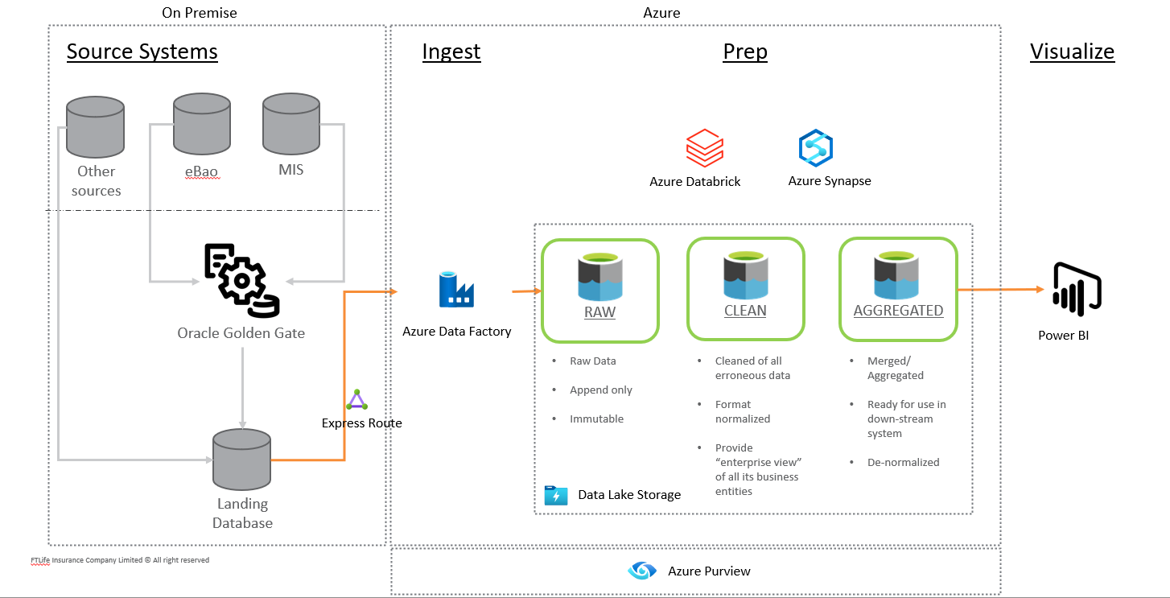

**Reference architecture for Operational Data Store & Customer 360 Data Store Solutions**

**Deliverables**: Data Strategy and Roadmap, Data Solution & Architecture Design (Application/Data/Infrastructure/Integration) and implementation of end to end flow

### 2.4.2 Data Model

The service provider is required to design data model based on insurance past experiences. The data model should be able to allow business users to self-service on the PowerBI, highly reusable & high scalability.

**Deliverables**: ERD and data dictionary and implementation

### 2.4.3 Migrate & Sunset Strategy

The service provider is required to suggest the data migration & sunset strategy to FTLife after implementing the EDW/data lake. The following tables display the number of reports in FTLife for different report types and departments. Section 2.4 shows FTLife preferred sunset strategy by phase on different report type/department.

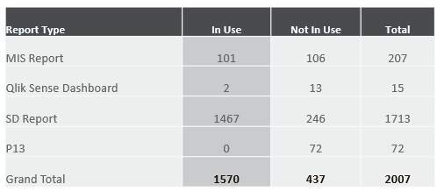

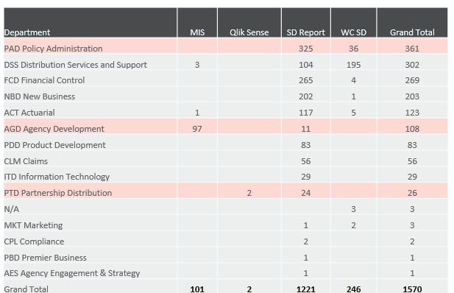

### 2.4.4 Data governance

The service provide should provide the data governance approach suitable for FTLife,

1. **Governance approach**: Propose a data governance approach that can operationalize the workflow & process to deliver both sensitive and non-sensitive data with approvals for various audiences across the organization.
2. **Data glossary and dictionary**: Define the data terminology to standardize the language across the organization.
3. **Data Quality, Metadata, Master Data Management**

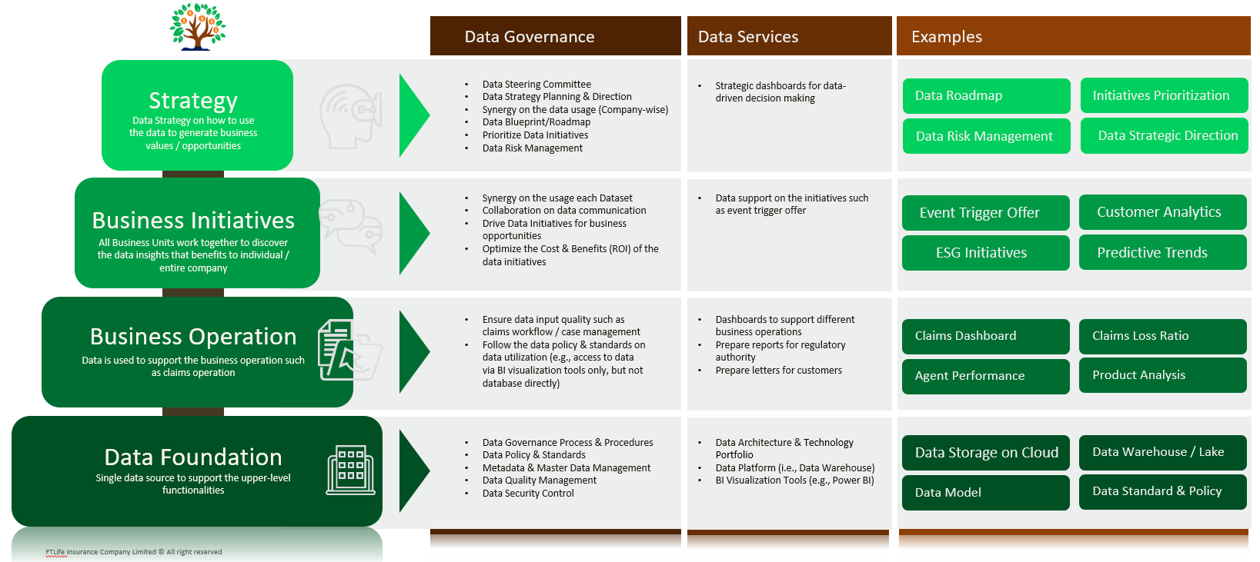

## 2.5 Delivery Approach

### 2.5.1 Design & Implementation Phase

EDW should be developed, implemented & delivered in an Agile way. It has following delivery requirements,

1. **Incremental Deliverables:** Deliverable should be delivered iteratively and it could be in technical deliverable or business deliverable
   1. Technical deliverable should be demonstrated as an enabler of business needs
   2. Business deliverable should be small enough to demonstrate partial business needs are fulfilled such as Part of Agency Dashboard
2. **Scrum Framework:** The design & implementation should be based on FTLife standard Scrum Framework. All scrum ceremonies should be followed including daily scrum, sprint planning, backlog grooming, sprint review & retrospective. Each sprint should define a sprint goal and the whole scrum team works towards the goal.
3. **MVP:** FTLife defines Minimum Viable Product (MVP) as the deliverables of multiple sprints which can deliver one of the approved business needs
4. **Ownership:** All the design documents, architecture diagram, data flow developed source codes and implementation related codes are owned by “FTLife Insurance Company Limited”.
5. **Financial:** The service provider is required to provide implementation costs with detail breakdown for different scopes in different phases.

|  |  |  |  |  |
| --- | --- | --- | --- | --- |
|  | **Phase 1**  **3 months** | **Phase 2**  **3 months** | **Phase 3**  **3 months** | **Phase 4**  **3 months** |
| **Business Domains** | Agency and Operation | Agency and Operation | Customer and Product | Partnership and other departments |
| **Scope** | * Data Foundation, Data model and Data governance * Agency Awards Report for Agent in Section 2.1.2 * Operation – Service Request in Section 2.1.4.1 | * Data model and Data governance (cont) * Agency Dashboards in Section 2.1.1 * Operation – NB Pending & Claims in Section 2.1.4.2 | * Data model and Data governance (cont) * Customer Analytics in Section 2.1.5 * Product Analysis in Section 2.1.6 | * Data model and Data governance (cont) * Partnership Dashboard in Section 2.1.3 * Other Service Requests from other departments (Example list in Appendix) |
| **Duration** | 6 sprints for each business domain | 6 sprints for each business domain | 6 sprints for each business domain | 6 sprints for each business domain |
| **Sunset** | 1. Manual version of Agency Awards Report (AAP) 2. Claims Dashboards in Data+ | 1. Agency Dashboards in Data+ and Talend ETL tools 2. 50% of MIS reports related to agency performance   *Includes MI113, MI124, MI127-129, MIS704-741, WCM020, WCM001-WCM159, SCM001 – SCM0081*   1. 10% of SD Reports and reduce 10% of SR ticket related to report generation | 1. 30% of SD Reports 2. Reduce 30% of SR ticket related to report generation | 1. IDS and Qlik Sense 2. 50% of SD Reports and reduce 50% of SR ticket related to report generation |
| **Financial** | To be provided by service provider   |  |  | | --- | --- | | **Impl. costs** | HKD in 3 months | | Data foundation, model and governance |  | | Agency Awards Reports |  | | Operation Service Request Extraction |  | | To be provided by service provider   |  |  | | --- | --- | | **Impl. costs** | HKD in 3 months | | Data model and governance |  | | Agency Dashboards |  | | Operation NB and Claims Dashboards |  | | To be provided by service provider   |  |  | | --- | --- | | **Impl. costs** | HKD in 3 months | | Data model and governance |  | | Customer Analytics |  | | Product Analysis |  | | To be provided by service provider   |  |  | | --- | --- | | **Impl. costs** | HKD in 3 months | | Data model and governance |  | | Partnership Dashboards |  | | Other department Service Request Extraction |  | |

### 2.5.2 Post-Implementation Phase

EDW is supported by FTLife internal CoE team and the service provider should ensure all the knowledges are transferred & well-documented for future maintenance. The service provider should provide the following,

1. Design & Implementation documents and deployment documents including Data Lake/EDW/ETL design documentations and technical specification
2. Knowledge transfer session & Training to FTLife team

## 2.6 Resource Allocation

Dedicated resource should be allocated to the project and different phase should have different subject domain expert to support & implement.

### 2.6.1 Data Architecture

Data Architect is involved for designing and ensure the governance of data architecture and data flow from synchronizing the data from source to target (Hybrid of Cloud and on-premise) with real-time and batch, ETL design and data model. The requirements of the data architect is listed as follows,

* Relevant Insurance experiences on data is a MUST
* Experiences in designing data model
* Experiences in large-scale EDW/data lake/lake house project from project start to end
* Experiences in Cloud solution including landing zone design, pros & cons of different clouds, data sync methodology
* Experiences in ETL & BI tools
* Cloud / On-premise high availability and backup design
* Effective monitoring for whole EDW / data lake architecture and operations
* Good command in Cantonese & English, Mandarin is a plus

### 2.6.2 Implementation

Data Governance Specialist, Data Engineer, Business Analyst and Cloud Engineer are involved for developing & implementing the EDW. The specialists should work together as a team to deliver business needs iteratively. The requirements of the Data Visualization Specialist and Data Engineer are as follows,

* Relevant Insurance experiences on data is a MUST
* Experiences in large-scale EDW project especially in implementation part
* Experiences in ETL tools, BI tools on building dashboard
* Good knowledge using Oracle & MS SQL
* Good communication

The requirements of the Cloud Engineer/specialist are as follows,

* Relevant Insurance experiences on data is a MUST
* Experiences in building Cloud solution including landing zone, multiple account setup and security
* Able to identify opportunities to deploy, optimize and protect critical applications and data storage
* Experiences in managing company data securely across multi-cloud environments
* Good communication

For Business Analyst, he/she is required to have good business knowledge on insurance.

### 2.6.3 On-site / Offshore Ratio

The service provider needs to state the **number of onsite and offshore** would be engaged in different phases of the project.

|  |  |  |  |  |
| --- | --- | --- | --- | --- |
|  | **Q1** | **Q2** | **Q3** | **Q4** |
| Onsite | *[Please fill in]*  *For example,*  *Data Architect x 1*  *Data Engineer x 2* | *[Please fill in]* | *[Please fill in]* | *[Please fill in]* |
| Offshore | *[Please fill in]*  *For example,*  *Data Modeler x 1*  *Data Governance Specialist x 1 Data Specialist x 2 Business Analyst x 2* | *[Please fill in]* | *[Please fill in]* | *[Please fill in]* |

### 2.6.4 Team structure for project phase & BAU phase

There are two team structures to be handled in different phases: Project phase and BAU phase. The project phase team structure should be able to **evolve** to the BAU phase after the project is completed. The service provider should help to manage the entire data project in the project phase, and help to communicate with the steering committee on the progress of the data project. The example of the data team structure evolution is shown as below,

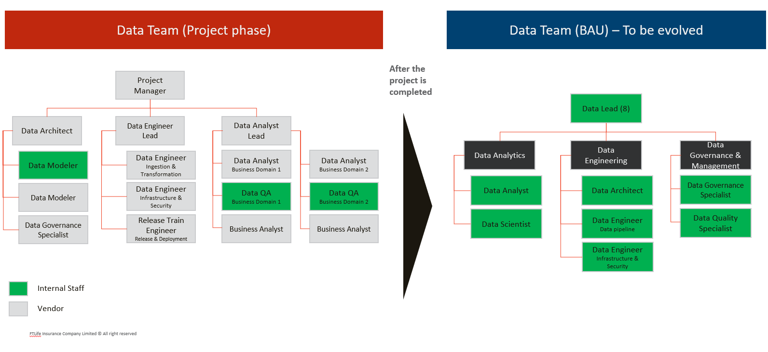

## 2.7 Data Security

1. No confidential information should be residence on the end user device
2. If there is need for storing the confidential or sensitive information in end user device, strong encryption which comply industrial standard is required.
3. Data in transit must be encrypted
4. If data are not stored in FTLife managed storage, proper physical security, network security and storage security should be applied to ensure data/information as well protected in terms of confidential, integrity and availability. Vendor should demonstrate how data security can be assured and FTLife could remain the data owner, exhibit control and revocation of data in case of data lose or suspect environment compromised.

## 2.8 Service Level and Incident Management

Ensure 99.9% monthly uptime for the service availability. On-site support shall be provided within 2 hours for critical incident. Prosper may propose the required resource as option to achieve the required service level.

For any planned maintenance, configuration change and/or software release, the proposer shall give notice to FTLife seven days in advance and should be held on a day which agreed with FTLife in advance.

For critical incident, which means system outage making the system impossible to use, the initial response time should be less than 30 minutes, the proposer shall provide the status update every 1 hour, and resolve the issue / provide a workaround solution within 4 hours

## 2.9 Project Governance Structure

The service provider is required to provide a project team structure that follows the high-level governance structure as shown in below structure. There is a Steering Committee to drive the overall direction to the team & help to resolve the escalation from the scrum teams. The service provider should allocate resources in the scrum teams for design & implementation.

# 3. Evaluation / Selection Approach

The evaluation and selection of solution will be undertaken in several stages as set out below:

1. FTLife sends RFP to selected service providers
2. Tender Briefing with Q & A session for service providers would be arranged (if necessary)
3. Service providers submit RFP response (TWO separated documents on technical proposal & financial proposal) to FTLife via FTShare platform – Late submission will not be considered
4. FTLife review the received proposals
5. FTLife follow up and clarify responses with service providers
6. Shortlisted service providers arrange presentation after RFP submission
7. FTLife rank service provider responses based on a FTLife scoring model
8. Short list of potential solutions:

* Reference checks
* Contract negotiation
* Selection of the preferred solution and vendor
* Contracting

We will select a service provider based on a combination of the ability and experience to meet specified requirements, the approach and deliverables, the ability to provide support during implementation and ongoing operation, and the full cost of ownership of the proposed solution.

The response to this RFP and any statements of capability made by the service provider during the evaluation process will be attached to and will form part of the final contract.

This section is included for information purposes only, to indicate the basic considerations of assessing proposals. It must not be assumed to be complete, final or ordered, and is subject to change without notice at the discretion of FTLife.

The general criteria by which proposals will be assessed include:

Evaluation Criteria

* Company profile, experience and management capability
* Operational competence; Experience in providing similar services; Team structure; Quality assurance program; Service level commitments, etc.
* Provision of value-added service
* Understanding FTLife requirements
* Service quality
* Price competitiveness

# 4. Response Format & Guidelines

## 4.1 Response Requirements

Responses to this RFP are to be in the form of a proposal submitted to FTLife in required format no later than the time specified in the email to the service provider. Failure to respond by the specified deadline or not conforming the required format will result in the respondent being excluded from the evaluation.

Responses should include a signed covering document summarizing key elements of the proposal such as the solution offered, timeframe, purchase price / license fees, on-going maintenance fees, costs of modification, implementation cost, and resources proposed to support implementation etc.

The Proposal should contain:

1. A signed with company chop of
   1. Form of Reply
   2. Confirmation Letter for Anti-Collusion
   3. Due Dilligence Questionnaire for Supplier
   4. Supplier Sustainability Questionnaire
2. A fully completed RFP Written Response (please refer to section 5 in this document, and directly provide input under that section) should include:

- Response sections clearly divided into the sections corresponding to the RFP Requirements

- Proposal information should address each numbered requirement items and deliverables

- Divide into technical proposal section and financial proposal section (Please be reminded that there is no pricing information should be stated in the technical proposal)

- Study Approach and methodology

- Proposed solution

- Implementation approach

- Time schedule, milestones, major tasks breakdown and allocated resources

- Price quotation on fixed cost basis, and yearly recurring cost for support and maintenance (if open source components are used, include free upgrade per quarter). Supplement sufficient details of cost breakdown

- Qualifications, relevant experience profiles and roles of involved key personnel

- Proposed onsite and offshore ratio

- Previous client’s reference of similar engagement and comments

1. Samples of deliverables and supporting documents

## 4.2 Additional Information

FTLife is prepared to accept additional information as part of the overall response. However, a response that does not include a fully completed RFP Written Response Document is deemed to be non-complying and will be excluded from the evaluation.

FTLife is not liable for any costs incurred by proposer in the preparation to this RFP and the subsequent evaluation tests.

Proposer should prepare the proposal independently without consultation, communication, agreement or arrangement with any competitors who had been requested by FTLife to submit this proposal. Proposer should understand that the accompanying proposal would be disqualified.

Quotations must be firm without escalation clauses. Proposers who are not prepared to offer a firm quotation must give full details of escalation clause they proposed and must provide such information as necessary to carry out an independent verification of increase requested under such a clause.

Proposer must itemize their proposal to provide individual pricing of all proposed services and components.

## 4.3 Timeline

|  |  |
| --- | --- |
| **Item** | **Tentative Date** |
| RFP issued by FTLife | 28th December 2022 |
| Supplier acknowledgement to bid | 29th December 2022  2:00pm (UTC+8) |
| Technical enquiry by service provider | 29th December 2022 – 6th January 2023 |
| RFP closing date and time | 3rd February 2023  2:00pm (UTC+8) |
| RFP presentation via Zoom by service provider  (By invitation only) | 6th February 2023 – 24th February 2023 |
| Contract award | March 2023 |

## 4.4 Format & Return of RFP Response to FTLife

Completed proposal and supporting materials should be in softcopy (TWO separated documents on technical proposal & financial proposal) and upload into the FTShare platform before the RFP Closing Date and Time. The upload link will be sent to the service provider by separate email. Please contact the designated Procurement in charge below for any enquiry of this RFP.

|  |
| --- |
| **Sherry Chiu**  FTLife Insurance Company Limited  7/F, NEO  123 Hoi Bun Road  Kwun Tong, Kowloon  E-mail: sherry.chiu@ftlife.com.hk |

# 5. Written Response

## 5.1 Vendor Information

### 5.1.1 Contact Details

**Vendor Details**

| Trading Name: |  |
| --- | --- |
| Registered Legal name: |  |
| Country of Incorporation: |  |
| Headquarters Address Line 1: |  |
| Line 2: |  |
| Line 3: |  |
| Line 4: |  |
| Line 5: |  |
| Hong Kong Address Line 1: |  |
| Line 2: |  |
| Line 3: |  |
| Line 4: |  |
| Line 5: |  |

**Account Executive responsible for FTLife:**

| Name: |  |
| --- | --- |
| Position: |  |
| Telephone Number: |  |
| E-mail Address: |  |
| Postal Address Line 1: |  |
| Line 2: |  |
| Line 3: |  |
| Line 4: |  |
| Line 5: |  |

**Primary Contact for questions related to this response:**

| Name: |  |
| --- | --- |
| Position: |  |
| Telephone Number: |  |
| E-mail Address: |  |
| Postal Address Line 1: |  |
| Line 2: |  |
| Line 3: |  |
| Line 4: |  |
| Line 5: |  |

**Secondary Contact for questions related to this response:**

| Name: |  |
| --- | --- |
| Position: |  |
| Telephone Number: |  |
| E-mail Address: |  |
| Postal Address Line 1: |  |
| Line 2: |  |
| Line 3: |  |
| Line 4: |  |
| Line 5: |  |

### 5.1.2 Size & Operating Performance

| Date the organization was established: |  |
| --- | --- |
| Date of incorporation: |  |
| Date of last published and fully audited accounts: |  |

Balance Sheet and Profit information for each of the past 5 years must be set out in the tables below. Row headings in each of the tables should be modified to show the actual financial each represented eg if the last year for which published and fully audited accounts are available was 2021 then “Year n” should be modified to read 2021, “Year n-1” should then be modified to read 2020. Each table must also have the “Currency” field at the top right updated for the currency used in each table.

**Balance Sheet Details (000’s) Currency:**

| **Item** | **Year n** | **Year n-1** | **Year n-2** | **Year n-3** | **Year n-4** |
| --- | --- | --- | --- | --- | --- |
| Paid Up Capital |  |  |  |  |  |
| Total Assets |  |  |  |  |  |
| Total Liabilities |  |  |  |  |  |

**Profit Details (000’s) Currency:**

| **Item** | **Year n** | **Year n-1** | **Year n-2** | **Year n-3** | **Year n-4** |
| --- | --- | --- | --- | --- | --- |
| Total Revenues |  |  |  |  |  |
| New Product License Fees |  |  |  |  |  |
| Maintenance Fees |  |  |  |  |  |
| Total profit |  |  |  |  |  |
| Profit Due To Normal Trading |  |  |  |  |  |
| Profit From Extraordinary Items |  |  |  |  |  |

**Location Details**

| Total Number of Worldwide Operating Locations: |  |
| --- | --- |

Details of specific countries of operation, Sales and support offices within each country and support provided by each support office must be set out in the table below.

| **Country of Operation** | **Sales Office Locations** | **Support Office Locations** | **Type of Support Provided** |
| --- | --- | --- | --- |
|  |  |  |  |
|  |  |  |  |

**Staff Numbers**

Details of staff numbers by function and location must be set out in the table below.

| **Location** | **Total Staff** | **Market / Sales** | **App’n Develop.** | **App’n Support** | **Imp. Support** | **Other** |
| --- | --- | --- | --- | --- | --- | --- |
| Worldwide |  |  |  |  |  |  |
| Home Geography |  |  |  |  |  |  |
| Hong Kong |  |  |  |  |  |  |
|  |  |  |  |  |  |  |

### 5.1.3 Current Projects and Resourcing

| **Project** | **Number of Full Time Equivalent Implementation Support Resources Engaged** | | | | | | | | | | | | | | | | | |
| --- | --- | --- | --- | --- | --- | --- | --- | --- | --- | --- | --- | --- | --- | --- | --- | --- | --- | --- |
| **Sep – Dec 2022** | | | | | | **Jan – Dec 2023** | | | | | | | | | | | |
| **J** | **A** | **S** | **O** | **N** | **D** | **J** | **F** | **M** | **A** | **M** | **J** | **J** | **A** | **S** | **O** | **N** | **D** |
| **1** | x | x | x | x | x | x |  |  |  |  |  |  |  |  |  |  |  |  |
| **2** | x | x | x | x | x | x |  |  |  |  |  |  |  |  |  |  |  |  |
| **3** | x | x | x | x | x | x |  |  |  |  |  |  |  |  |  |  |  |  |
| **4** | x | x | x | x | x | x |  |  |  |  |  |  |  |  |  |  |  |  |
| **5** | x | x | x | x | x | x |  |  |  |  |  |  |  |  |  |  |  |  |
| **….** | x | x | x | x | x | x |  |  |  |  |  |  |  |  |  |  |  |  |
| **N** | x | x | x | x | x | x |  |  |  |  |  |  |  |  |  |  |  |  |

### 5.1.4 Contract Sample

FTLife’s standard contract for this proposal is attached below. Identify specific contract terms to which your response will be in non-compliance.

{Enter Response}



### 5.1.5 Project Reference

Please supplement Project reference

|  |  |
| --- | --- |
| Any services/project/support/maintenance working/providing to FTLife currently?  (if Yes, please supplement with 3 project/services that currently working with/for FTLife) |  |
| Any previous experience with FTLife on related services / products  (if Yes, please supplement with 3 project/services that work with/for FTLife) |  |
| Any previous experience in other FSI companies  (If Yes, please supplement 3 key companies projects) |  |
| Any previous experience in similar size projects  (If Yes, please supplement with 3 projects) |  |

** In case NDA in place you not able to disclose the company/project name. Please specify and share us the company size, primary business nature and the project nature your worked with them

## 5.2 Proposed Solution

### 5.2.1 Reference Sites

The vendor should provide the following details for each reference provided.

| Client Company Name: |  |
| --- | --- |
| Contact Person: |  |
| Contact’s Position and Title: |  |
| Contact’s Telephone Number: |  |
| Contact’s E-mail Address: |  |
| Contacts Address Line 1: |  |
| Line 2: |  |
| Line 3: |  |
| Line 4: |  |
| Line 5: |  |

### 5.2.2 Technical Proposal Section

|  |  |
| --- | --- |
| Section | Item Details |
|  |  |
|  |  |
|  |  |
|  |  |
|  |  |

### 5.2.3 Financial Proposal Section

FTLife’s standard contract for this proposal is attached below. Identify specific contract terms to which your response will be in non-compliance.

{Enter Response}



### 5.2.4 Demonstrations / Presentations

[Please fill in Demonstrations / Presentations info with attachments.]

### 5.2.5 Sample Documents / Outputs

[Please attach all relevant Sample Documents / Output as supporting.]

### 5.2.6 Implementation Approach

[Please fill in Implementation Approach.]

# 6. Appendix

## 6.1 AAP report List

| **Report #** | **Report Name** | **Report Name 2** |
| --- | --- | --- |
| A1.1 | 總盟主 | 總盟主  Report fields:  1. 區域 WCM011B : [ Region_Name ]  2. 分區 WCM011B : [ District_Code ]  3. 營業組別 WCM011B : [ Unit_Code ]  4. 代理人編號 WCM011B: [ Producer_Code ]  5. 姓名 MI129_data : [ Agent Name ] for non-dummy agent  WCM011B : [ Region_Name ] for dummy agent  6. 職級 WCM011B : [Producer_Title] (show"-" for dummy agent)  7. 已批核直屬區域首年佣金 (FYC)  ~ AAP_Downline_Detail_(YYYYMM) : sum of [ ISS_TTL_FYC ] for all months [PRDN_MONTH] in current year  then deduct sum of [FYC_App to discount] of agent marked as "Yes" from corresponding managers in the Nuera Adjustment file  8. 下線業績續保率 % WCM020B : [PERSIST_RATE_19MTH ] x 100 , where  [PRDN_MONTH] use latest month only  [PRODUCTION] use "AFYC" only  [PRODUCTION_CATEGORY] use "Downline" only  9. 排名 Display "1" for top qualifier based on 已批核直屬區域首年佣金 (FYC) while 下線業績續保率 % >= 80  10. 下線業績續保率 % (LIMRA 25) WCM020C : [PERSIST_RATE_19MTH ] x 100 , where  [PRDN_MONTH] use latest month only  [PRODUCTION] use "AFYC" only  [PRODUCTION_CATEGORY] use "Downline" only |
| A1.2 | Executive / Senior Regional Director of the Year | 行政及高級區域總監 - 全組最高首年佣金  Report fields:  1. 區域 WCM011B : [ Region_Name ]  2. 分區 WCM011B : [ District_Code ]  3. 營業組別 WCM011B : [ Unit_Code ]  4. 代理人編號 WCM011B: [ Producer_Code ]  5. 姓名 MI129_data : [ Agent Name ] for non-dummy agent  WCM011B : [ Region_Name ] for dummy agent  6. 職級 WCM011B : [Producer_Title] (show"-" for dummy agent)  7. 已批核全組首年佣金 (FYC)  ~ AAP_Downline_Detail_(YYYYMM) : sum of [ ISS_TTL_FYC ] for all months [PRDN_MONTH] in current year  ~ then, according to hierarchy WCM005 at 31-Mar-report year, add up self's and direct/indirect downline RD/SRD/ERD's 已批核直屬區域首年佣金 (FYC)  ~ then deduct sum of [FYC_App to discount] of agent marked as "Yes" from corresponding managers in the Nuera Adjustment file  8. 下線業績續保率 % WCM020B : [PERSIST_RATE_19MTH ] x 100 , where  [PRDN_MONTH] use latest month only  [PRODUCTION] use "AFYC" only  [PRODUCTION_CATEGORY] use "Downline" only  9. 排名 Display "1" / "2" for top 2 qualifiers based on 已批核全組首年佣金 (FYC) while 下線業績續保率 % >= 80  10. 下線業績續保率 % (LIMRA 25) WCM020C : [PERSIST_RATE_19MTH ] x 100 , where  [PRDN_MONTH] use latest month only  [PRODUCTION] use "AFYC" only  [PRODUCTION_CATEGORY] use "Downline" only |
| A1.2 | Executive / Senior Regional Director of the Year | 行政及高級區域總監 - 直屬區域最高首年佣金  Report fields:  1. 區域 WCM011B : [ Region_Name ]  2. 分區 WCM011B : [ District_Code ]  3. 營業組別 WCM011B : [ Unit_Code ]  4. 代理人編號 WCM011B: [ Producer_Code ]  5. 姓名 MI129_data : [ Agent Name ] for non-dummy agent  WCM011B : [ Region_Name ] for dummy agent  6. 職級 WCM011B : [Producer_Title] (show"-" for dummy agent)  7. 已批核直屬區域首年佣金 (FYC)  ~ AAP_Downline_Detail_(YYYYMM) : sum of [ ISS_TTL_FYC ] for all months [PRDN_MONTH] in current year    8. 下線業績續保率 % WCM020B : [PERSIST_RATE_19MTH ] x 100 , where  [PRDN_MONTH] use latest month only  [PRODUCTION] use "AFYC" only  [PRODUCTION_CATEGORY] use "Downline" only  9. 排名 Display "1" / "2" for top 2 qualifier based on 已批核直屬區域首年佣金 (FYC) while 下線業績續保率 % >= 80  10. 下線業績續保率 % (LIMRA 25) WCM020C : [PERSIST_RATE_19MTH ] x 100 , where  [PRDN_MONTH] use latest month only  [PRODUCTION] use "AFYC" only  [PRODUCTION_CATEGORY] use "Downline" only |
| A1.2 | Executive / Senior Regional Director of the Year | 行政及高級區域總監 - 最高平均生產力  Report fields:  1. 區域 WCM011B : [ Region_Name ]  2. 分區 WCM011B : [ District_Code ]  3. 營業組別 WCM011B : [ Unit_Code ]  4. 代理人編號 WCM011B: [ Producer_Code ]  5. 姓名 MI129_data : [ Agent Name ] for non-dummy agent  WCM011B : [ Region_Name ] for dummy agent  6. 職級 WCM011B : [Producer_Title] (show"-" for dummy agent)  7. 下線業績續保率 % WCM020B : [PERSIST_RATE_19MTH ] x 100 , where  [PRDN_MONTH] use latest month only  [PRODUCTION] use "AFYC" only  [PRODUCTION_CATEGORY] use "Downline" only  8. 已批核首年佣金 (>= 6,000,000)  AAP_Downline_Detail_(YYYYMM) : sum of [ ISS_TTL_FYC ] for all months [PRDN_MONTH] in current year  9. 平均生產力  Sum all calendar months' productivity since Jan-ReportYear, divided by number of calendar months since Jan-ReportYear, where a calendar month's productivity is that month's [ ISS_TTL_FYC ] divided by *number of agents in that month.  *Number of agents = number of agents/managers with [Agent Status] = "Infoce" in MI129_data in downline grouping  ~ need to excl. dummy code 219983, exclude those with [Agent_Role] = "Internship" / "HKFI CPD" / "Secretary" and [Role_Expiry_Period] = "01-Jan-2099" when calculating number of agents  10. 排名 Display "1" for top qualifier based on 平均生產力, while 下線業績續保率 % >= 80 and 已批核首年佣金 >= 6,000,000  11. 下線業績續保率 % (LIMRA 25) WCM020C : [PERSIST_RATE_19MTH ] x 100 , where  [PRDN_MONTH] use latest month only  [PRODUCTION] use "AFYC" only  [PRODUCTION_CATEGORY] use "Downline" only |
| A1.2 | Executive / Senior Regional Director of the Year | 行政及高級區域總監 - 最高增長  Report fields:  1. 區域 WCM011B : [ Region_Name ]  2. 分區 WCM011B : [ District_Code ]  3. 營業組別 WCM011B : [ Unit_Code ]  4. 代理人編號 WCM011B: [ Producer_Code ]  5. 姓名 MI129_data : [ Agent Name ] for non-dummy agent  WCM011B : [ Region_Name ] for dummy agent  6. 職級 WCM011B : [Producer_Title] (show"-" for dummy agent)  7. 下線業績續保率 % WCM020B : [PERSIST_RATE_19MTH ] x 100 , where  [PRDN_MONTH] use latest month only  [PRODUCTION] use "AFYC" only  [PRODUCTION_CATEGORY] use "Downline" only  8. 2021 已批核首年佣金  AAP_Downline_Detail_(YYYYMM) : sum of [ ISS_TTL_FYC ] for all months [PRDN_MONTH] in current year  9. 2020 已批核首年佣金 (>= 6,000,000)  Manager_Base : [Min] It's a manual report prepared by user  10. 增長率(%)  ( 2021 已批核首年佣金 - 2020 已批核首年佣金 ) x 100, round to 1 decimal  11. 排名  Display "1" for top qualifier based on 增長率(%), while  增長率(%) >= 20 and 下線業績續保率 % >= 80  12. 下線業績續保率 % (LIMRA 25) WCM020C : [PERSIST_RATE_19MTH ] x 100 , where  [PRDN_MONTH] use latest month only  [PRODUCTION] use "AFYC" only  [PRODUCTION_CATEGORY] use "Downline" only |
| A1.2 | Executive / Senior Regional Director of the Year | 行政及高級區域總監 - 最高平均舉績率  Report fields:  1. 區域 WCM011B : [ Region_Name ]  2. 分區 WCM011B : [ District_Code ]  3. 營業組別 WCM011B : [ Unit_Code ]  4. 代理人編號 WCM011B: [ Producer_Code ]  5. 姓名 MI129_data : [ Agent Name ] for non-dummy agent  WCM011B : [ Region_Name ] for dummy agent  6. 職級 WCM011B : [Producer_Title] (show"-" for dummy agent)  7. 下線業績續保率 % WCM020B : [PERSIST_RATE_19MTH ] x 100 , where  [PRDN_MONTH] use latest month only  [PRODUCTION] use "AFYC" only  [PRODUCTION_CATEGORY] use "Downline" only  8. 平均舉績率(%)  Sum all calendar months' 舉績率 since Jan-ReportYear, divided by number of calendar months since Jan-ReportYear, where  1 calendar month's 舉績率 = No. of "Acitve Agents" as of month-end, divided by No. of "Agents" as of monthend x 100, round to 1 decimal. Downline grouping for "Active Agent" / "Agent" refer to next row#  "Agents" = Agent/Manager with MI129_data [Agent_Status] = "Inforce" (if less than 45, take 45), excluding those  a. with WCM011B [Agent_Role] = "Internship" / "HKFI CPD" / "Secretary" and [Role_Expiry_Period] = "01-Jan-2099"  b. with WCM011B [Contract_Effective_Date] fall in the same calendar month  c. dummy agent    "Active Agents" = Agent/Manager with MI129_data [Agent_Status] = "Inforce", whose *Case_Count >= 1, excluding those  a. with WCM011B [Agent_Role] = "Internship" / "HKFI CPD" / "Secretary" and [Role_Expiry_Period] = "01-Jan-2099"  b. with WCM011B [Contract_Effective_Date] fall in the same calendar month  c. dummy agent  where, 3 PA_Case_Count can replace 1 Case_Count (maxiumn 5% of 舉績率 come from Agents using PA_Case_Count to qualify as Active Agent)  * Case_Count = sum of AAP_Benefit_Detail [Case_Count] with [PRDN_CAUSE] = 1,2,3,7  * PA_Case_Count" = sum of AAP_Benefit_Detail [PA_Case_Count] with [PRDN_CAUSE] = 1,2,3,7  9. 排名 Display "1" for top qualifier based on 平均舉績率(%), while 下線業績續保率 % >= 80 and 平均舉績率(%) >= 60  10. 下線業績續保率 % (LIMRA 25) WCM020C : [PERSIST_RATE_19MTH ] x 100 , where  [PRDN_MONTH] use latest month only  [PRODUCTION] use "AFYC" only  [PRODUCTION_CATEGORY] use "Downline" only |
| A1.2 | Executive / Senior Regional Director of the Year | 行政及高級區域總監 -連續12個月達至60%舉績率  Report Fields  1. 區域  2. 分區  3. 營業組別  4. 代理人編號  5. 姓名  6. 職級  7. 下線業績續保率 %  8. 達至60%舉績率月份次數 |
| A1.3 | Regional Director of the Year | 區域總監 - 最高首年佣金 |
| A1.3 | Regional Director of the Year | 區域總監 - 最高平均生產力 |
| A1.3 | Regional Director of the Year | 區域總監 - 最高增長 |
| A1.3 | Regional Director of the Year | 區域總監 - 最高平均舉績率 |
| A1.3 | Regional Director of the Year | 區域總監 - 連續12個月達至60%舉績率 |
| A1.4 | 10 Million Region | 千萬元區域大獎  Report Fields  1. 區域  2. 分區  3. 營業組別  4. 代理人編號  5. 姓名  6. 職級  7. 已批核首年佣金 (FYC)  8. 增長率(%)大於零  9. 下線業績續保率 %  10. 區域大獎  11. 下線業績續保率 % (LIMRA25) |
| A1.5 | District Director of the Year | 分區總監王  Report Fields  1. 區域  2. 分區  3. 營業組別  4. 代理人編號  5. 姓名  6. 職級  7. 下線業績續保率 %  8. 2021 已批核首年佣金  9. 2020 已批核首年佣金 (>= 3,000,000)  10. 增長率(%)  11. 排名  12. 下線業績續保率 % (LIMRA25) |
| A1.5 | District Director of the Year | 分區總監 - 最高首年佣金 |
| A1.5 | District Director of the Year | 分區總監 - 最高平均生產力 |
| A1.5 | District Director of the Year | 分區總監 - 最高增長 |
| A1.6 | Senior District Manager / District Manager of the Year | 高級分區經理及分區經理王 |
| A1.6 | Senior District Manager / District Manager of the Year | 高級分區經理及分區經理 - 最高首年佣金 |
| A1.6 | Senior District Manager / District Manager of the Year | 高級分區經理及分區經理 - 最高平均生產力 |
| A1.6 | Senior District Manager / District Manager of the Year | 高級分區經理及分區經理 - 最高增長 |
| A1.7 | Senior Agency Manager of the Year | 高級分行經理王 |
| A1.7 | Senior Agency Manager of the Year | 高級分行經理 - 最高首年佣金 |
| A1.7 | Senior Agency Manager of the Year | 高級分行經理 - 最高增長 |
| A1.8 | Agency Manager of the Year | 分行經理王 |
| A1.8 | Agency Manager of the Year | 分行經理 - 最高首年佣金 |
| A1.8 | Agency Manager of the Year | 分行經理 -最高增長 |
| A1.9 | Leaders Club | 領袖榮譽會 |
| A2 | Recruitment | 傑出招募區域大獎 |
| A2 | Recruitment | 招募王 |
| A2 | Recruitment | 傑出招募經理大獎 |
| A2 | Recruitment | 傑出招募營業經理大獎 |
| A2 | Recruitment | LEAP & Beyond優質區域招募大獎 |
| A2 | Recruitment | LEAP & Beyond優質區域招募大獎 (Detail) |
| A2 | Recruitment | LEAP & Beyond 優質經理招募大獎 |
| A2 | Recruitment | 優才經理會 |
| A3.1 | Achiever of the Year | 業績王  Report Fields:  1. 區域  2. 分區  3. 營業組別  4. 代理人編號  5. 姓名  6. 職級  7. 已批核 FYC 總數  8. 已批核 保單數目  9. 個人業績續保率 %  10. 任職年期  11. 「業績榮譽會」會員資格  12. 排名  13. 個人業績續保率 % (LIMRA 25) |
| A3.2 | Achiever Club | Achiever Club  Report Fields:  1. 區域  2. 分區  3. 營業組別  4. 代理人編號  5. 姓名  6. 職級  7. 個人業績續保率 %  8. FYC 總數  9. 壽險保單數目  10. 以PA保單取代之保單數目  11. 總保單數目  12. 「業績榮譽會」會員資格  13. 與進一級獎項FYC 目標差額  14. 傑出代理人大獎排名  15. 個人業績續保率 % (LIMRA 25) |
| A4.1 | Case Achiever of the Year | 保單王  Report Fields:  1. 區域  2. 分區  3. 營業組別  4. 代理人編號  5. 姓名  6. 職級  7. 已批核FYC 總數  8. 已批核保單數目  9. 以PA保單取代之保單數目  10. 總保單數目  11. 個人業績續保率 %  12. 任職年期  13. 「保單榮譽會」會員資格  14. 排名  15. 個人業績續保率 % (LIMRA 25) |
| A4.2 | Health Case Achiever of the Year | Health Case  Report Fields:  1. 區域  2. 分區  3. 營業組別  4. 代理人編號  5. 姓名  6. 職級  7. 已批核醫療及危疾保單FYC  8. 已批核醫療及危疾保單數目  9. 個人業績續保率 %  10. 排名  11. 個人業績續保率 % (LIMRA 25) |
| A4.3 | Cases Club | Case Club  Report Fields:  1. 區域 WCM011B : [ Region_Name ]  2. 分區 MI129_data : [ District ]  3. 營業組別 MI129_data : [ Unit ]  4. 代理人編號 MI129_data: [ Agent ]  5. 姓名 MI129_data : [ Agent Name ]  6. 職級 MI129_data : [ Title ]  7. 個人業績續保率 % WCM020B : [PERSIST_RATE_19MTH ] x 100 , where  [PRDN_MONTH] use latest month only  [PRODUCTION] use "AFYC" only  [PRODUCTION_CATEGORY] use "Personal" only  8. 已批核FYC 總數 AAP_Policy_Detail_(YYYYMM) : [ ISS_TTL_FYC ]  ~ Sum up of all months in reporting year based on [PRDN_MONTH]  9. 已批核壽險保單數目 AAP_Policy_Detail_(YYYYMM) : [ ISS_TTL_CASE ]  ~ Sum up of all months in reporting year based on [PRDN_MONTH]  10. 排名 (refer to A4.3.7)  11. 以PA保單取代之保單數目 AAP_Policy_Detail_(YYYYMM) : [ ISS_TTL_PA_CASE ]  ~ Sum up of all months in reporting year based on [PRDN_MONTH]  ~ Convert every 3 PA cases into 1 壽險保單數目  12. 總保單數目  ~ 壽險保單數目 + 以PA保單取代之保單數目  13. 「保單榮譽會」會員資格 (refer to A4.3.5)  14. 與進一級獎項保單數目目標差額 (refert to A.3.8)  15. 個人業績續保率 % WCM020C : [PERSIST_RATE_19MTH ] x 100 , where  [PRDN_MONTH] use latest month only  [PRODUCTION] use "AFYC" only  [PRODUCTION_CATEGORY] use "Personal" only |
| A4.4 | Active Club | 毅力會 |
| A5.1 | Rookie of the Year | 新人王  Report Fields:  1. 區域 WCM011B : [ Region_Name ]  2. 分區 MI129_data : [ District ]  3. 營業組別 MI129_data : [ Unit ]  4. 代理人編號 MI129_data: [ Agent ]  5. 姓名 MI129_data : [ Agent Name ]  6. 職級 MI129_data : [ Title ]  7. 已批核FYC 總數 AAP_Policy_Detail_(YYYYMM) : [ ISS_TTL_FYC ]  ~ Sum up of all months in reporting year based on [PRDN_MONTH]  8. 已批核保單數目 AAP_Policy_Detail_(YYYYMM) : [ ISS_TTL_CASE ]  ~ Sum up of all months in reporting year based on [PRDN_MONTH]  9. 個人業績續保率 % WCM020B : [PERSIST_RATE_19MTH ] x 100 , where  [PRDN_MONTH] use latest month only  [PRODUCTION] use "AFYC" only  [PRODUCTION_CATEGORY] use "Personal" only  10. 會員資格 (refer to A5.1.5)  11. 排名 (refer to A5.1.7)  12. 個人業績續保率 % WCM020C : [PERSIST_RATE_19MTH ] x 100 , where  [PRDN_MONTH] use latest month only  [PRODUCTION] use "AFYC" only  [PRODUCTION_CATEGORY] use "Personal" only |
| A5.2 | Rookie Club | Rookie Club  Report Fields:  1. 區域 WCM011B : [ Region_Name ]  2. 分區 MI129_data : [ District ]  3. 營業組別 MI129_data : [ Unit ]  4. 代理人編號 MI129_data: [ Agent ]  5. 姓名 MI129_data : [ Agent Name ]  6. 職級 MI129_data : [ Title ]  7. 已批核FYC 總數 AAP_Policy_Detail_(YYYYMM) : [ ISS_TTL_FYC ]  ~ Sum up of all months in reporting year based on [PRDN_MONTH]  8. 已批核保單數目 AAP_Policy_Detail_(YYYYMM) : [ ISS_TTL_CASE ]  ~ Sum up of all months in reporting year based on [PRDN_MONTH]  9. 個人業績續保率 % WCM020B : [PERSIST_RATE_19MTH ] x 100 , where  [PRDN_MONTH] use latest month only  [PRODUCTION] use "AFYC" only  [PRODUCTION_CATEGORY] use "Personal" only  10. 會員資格 (refer to A5.2.5)  11. 距離下一級資格FYC目標差距 (refer to A5.2.6)  12. 距離下一級資格保單數目目標差距 (refert to A5.2.7)  13. 排名 (refer to A5.2.9)  14. 個人業績續保率 % WCM020C : [PERSIST_RATE_19MTH ] x 100 , where  [PRDN_MONTH] use latest month only  [PRODUCTION] use "AFYC" only |
| A6.1 | Long Service Award | Long Service 5,10,15 yr  Report Fields:  1. 區域 WCM011B : [ Region_Name ]  2. 分區 MI129_data : [ District ]  3. 營業組別 MI129_data : [ Unit ]  4. 代理人編號 MI129_data: [ Agent ]  5. 姓名 MI129_data : [ Agent Name ]  6. 職級 MI129_data : [ Title ]  7. 已批核 FYC AAP_Policy_Detail_(YYYYMM) : [ ISS_TTL_FYC ]  ~ Sum up of all months in reporting year based on [PRDN_MONTH]  8. 入職年期 (refer to A6.1.3)  9. 個人業績續保率 % WCM020B : [PERSIST_RATE_19MTH ] x 100 , where  [PRDN_MONTH] use latest month only  [PRODUCTION] use "AFYC" only  [PRODUCTION_CATEGORY] use "Personal" only  10. 與第一名之FYC 目標差額  11. 排名 (refer to A6.1.6)  12. 個人業績續保率 % WCM020C : [PERSIST_RATE_19MTH ] x 100 , where  [PRDN_MONTH] use latest month only  [PRODUCTION] use "AFYC" only  [PRODUCTION_CATEGORY] use "Personal" only |
| A6.2 | Long Service Award | Long Service 20 yr  Report Fields:  1. 區域 WCM011B : [ Region_Name ]  2. 分區 MI129_data : [ District ]  3. 營業組別 MI129_data : [ Unit ]  4. 代理人編號 MI129_data: [ Agent ]  5. 姓名 MI129_data : [ Agent Name ]  6. 職級 MI129_data : [ Title ]  7. 已批核 FYC AAP_Policy_Detail_(YYYYMM) : [ ISS_TTL_FYC ]  ~ Sum up of all months in reporting year based on [PRDN_MONTH]  8. 入職年期 (refer to A6.2.3)  9. 個人業績續保率 % WCM020B : [PERSIST_RATE_19MTH ] x 100 , where  [PRDN_MONTH] use latest month only  [PRODUCTION] use "AFYC" only  [PRODUCTION_CATEGORY] use "Personal" only  10. 達標 (refer to A6.2.5)  11. 個人業績續保率 % WCM020C : [PERSIST_RATE_19MTH ] x 100 , where  [PRDN_MONTH] use latest month only  [PRODUCTION] use "AFYC" only  [PRODUCTION_CATEGORY] use "Personal" only |
| A6.3 | Long Service Award | 忠誠王  Report Fields:  1. 區域  2. 分區  3. 營業組別  4. 代理人編號  5. 姓名  6. 職級  7. 已批核 FYC  8. 入職年期  9. 個人業績續保率 %  10. 達標  11. 個人業績續保率 % (LIMRA 25) |
| B2 | Most MDRT Region | 百萬金鑽區域大獎 及 百萬金鑽區域會  Report fields:  1. 區域 WCM011B : [ Region_Name ]  2. 分區 WCM011B : [ District ]  3. 營業組別 WCM011B : [ Unit ]  4. 代理人編號 WCM011B: [ Producer_Code ]  5. 姓名 MI129_data : [ Agent Name ] for non-dummy agent code  WCM011B : [Region_Name] for Dummy agent code  6. 職級 WCM011B : [Producer_Title]  7. 下線業績續保率 % WCM020B : [PERSIST_RATE_19MTH ] x 100 , where  [PRDN_MONTH] use latest month only  [PRODUCTION] use "AFYC" only  [PRODUCTION_CATEGORY] use "Downline" only  8. 區域總人數  ~ Count of Agent/Manager with [Agent_Status] = "Inforce" in MI129_Data but exclude agent code 219983  ~ also exclude those  a. with [Agent_Role] = "Internship" / "Secretary" / "HKFI CPD" and  [Role_Expiry_Period] = "01-01-2099" (refer to WCM011B)  b. those whose [Contract_Effective_Date] (refer to WCM011B) fall in the same month of the report's as-of-date  ~ Then grouping based on [Region_Code] in WCM011B as of 31-Mar of the reporting year.  ~For Agent/Manager whose [Contracdt_Effective_Date] > 31-Mar-reporting year, use [Region_Code] in current WCM011B (aligned with the report's as of date), then take the maximum of 45 and calculated figure for each region  (note: should provide flexiblity to handle splitting/combining regions upon occurance) |
| B4 | Most MDRT Leader | 百萬金鑽領袖大獎 及 百萬金鑽領袖會  Report fields:  1. 區域 WCM011B : [ Region_Name ]  2. 分區 MI129_data : [ District ]  3. 營業組別 MI129_data : [ Unit ]  4. 代理人編號 MI129_data: [ Agent ]  5. 姓名 MI129_data : [ Agent Name ]  6. 職級 WCM011B : [Producer_Title]  7. 下線業績續保率 % WCM020B : [PERSIST_RATE_19MTH ] x 100 , where  [PRDN_MONTH] use latest month only  [PRODUCTION] use "AFYC" only  [PRODUCTION_CATEGORY] use "Downline" only  8. 百萬圓桌會會員人數  Count of Agent/Manager with [Awards] <> blank (or = "MDRT", "COT", "TOT") in MDRT file and based on [Unit] (refer to MI129_data as of 31-Mar of the reporting year). For Agent/Manager whose [Contract_Effective_Date] > 31-Mar-reporting year, use [Unit] in current MI129 (aligned with the report's as of date)  9. 百萬金鑽領袖會 (refer to B4.5)  10. 百萬金鑽領袖大獎  ~ 達至最多MDRT會員； 及  ~ MDRT會員人數達至6人或以上  ~ 下線業績續保率% >= 80%  ~ 若百萬圓桌會會員人數相同，則以百萬圓桌會會員人數divided by 營業組別人數 比例較高者計算  營業組別人數 = Count of Agent/Manager with [Agent_Status] = "Inforce" in MI129 and based on [Unit] (refer to MI129_data as of 31-Mar-reporting year). For Agent/Manager whose [Contract_Effective_Date] > 31-Mar of the reporting year, use [Unit] in current MI129 (aligned with the report's as of date) |

|  |  |
| --- | --- |
| Report # | Report Name |
| B1 | Million Dollar Round Table 百萬圓桌會 |

| **Report** | **Report Name** |
| --- | --- |
| D2.1 | CMF (傑出個人獎) |
| D2.2 | CMF (優秀主管獎) |
| D3.1 | IDA (傑出業務獎) |
| D3.2 | IDA (優秀主管獎) |
| D4.1 | QLA (優質領袖大獎) |
| D4.2 | QMA (優質經理大獎) |
| D4.3 | QAA (優質顧問大獎) |
| D5.1 | GAMA MAA (最高管理成就獎) |
| D5.2 | GAMA IMA (管理卓越獎) |
| D5.3 | GAMA FLA (管理發展獎) |
| D5.4 | GAMA LBA (經理指標大獎) |
| D5.5 | GAMA RMA (新晉經理獎) |
| D5.6 | GAMA BGA (最佳躍進獎) |
| D5.7 | GAMA TRA (最佳招募獎) |
| D6 | IQA (國際卓越品質獎) |
| D7.1 | CIA500 (世界華人保險500強團隊) - 皇冠級 |
| D7.2 | CIA500 (世界華人保險500強團隊) - 桂冠級 |
| D8.1 | LUA NewStar (保協傑出新星獎) (上半年度) |
| D8.2 | LUA NewStar (保協傑出新星獎) (下半年度) |
| D9.1 | APFinSA Awards (Agent) |
| D9.2 | APFinSA Awards (Leadership) |

## 6.2 Application list in used for FTLife

| **S/N** | **Service / Application** |
| --- | --- |
|  |
| 1 | 238 - Customer Service App (P10) |  |
| 2 | 245 - CRM (P14) |  |
| 3 | 231 Electronic New Business Application Center (P02) |  |
| 4 | 108 Mobile POS |  |
| 5 | AUWMuni |  |
| 6 | SASAML |  |
| 7 | 132 Anti-Money Laundry (World Check) Reporting |  |
| 8 | 246 IFRS9 |  |
| 9 | 163 Group System (I21-Informix) |  |
| 10 | 120 Agency Awards and Contest System |  |
| 11 | 157 General Insurance (MPF Business) |  |
| 12 | 148 DataFeed for Partnership |  |
| 13 | 180 MIS |  |
| 14 | 198 QlikSense |  |
| 15 | 139 Mobile Applications (CDA Only) |  |
| 16 | 240 eRecruit |  |
| 17 | 234 Payment Platform (P05) |  |
| 18 | 232 Customer Service Center (P03) |  |
| 19 | 146 CSM System (Siebel) |  |
| 20 | [eBao] 101 eBao Life - U/W 102 eBao - Agency 101 eBao Life - Claims 101 eBao Life - Valuation 101 eBao Life - Finance 101 eBao Life - Policy Administration 101 eBao Life - Product |  |
| 21 | [APPIAN Applications] 128 Agent Debt System (ADSA) 170 I21SA 144 Complaints Monitoring (CMSA) 138 Payment Administration & Control (PACSA) 127 Agent Account Process (AAPSA) |  |
| 22 | 122 Agency Document Management System (AODMS) |  |
| 23 | 124 Agency Training (Course Administration) |  |
| 24 | 126 Agency Training Portal |  |
| 25 | 233 Management Performance Dashboard (P06) |  |
| 26 | 235 Sales Management System (P06) |  |
| 27 | 236 Agency Campaign (P06) |  |
| 28 | 237 Mobile Business Development App (P08/P09) |  |
| 30 | [BOSS Applications] 104 BOSS - Agent Portal 106 BOSS - Financial Express 105 BOSS - IFA / CA Portal 103 BOSS - Customer Portal |  |
| 31 | 200 eBooking |  |
| 32 | 195 Partnership Concierge Service Desk (Fresh Desk) |  |
| 33 | 193 iConnect |  |
| 34 | 171 Corporate Website |  |
| 35 | 140 Client Campaign (Data Extraction from eBao's DB) |  |
| 36 | 182 MPF (data for enquiry) |  |
| 37 | 184 ORSO (data for enquiry) |  |
| 38 | 137 - MS Office 365 |  |
| 39 | P01 - RPA |  |
| 40 | 134 - AMDP |  |
| 41 | 152 - Finance - Reinsurance Billing |  |
| 42 | 166 - Hardcat System |  |
| 43 | 167 - HRMS |  |
| 44 | 168 - HiPortfolio |  |
| 45 | 190 - Sun Accounting |  |

## 6.3 Service Request (SR) Ticket Examples

| **Reqeust Name** | **Service Description** |
| --- | --- |
| (eBao Life)Ad-hoc data request | Please reterive the claims data (settled claim case) for the period: 1 Jan 2019-31 Dec 2019.  Data |
| (eBao Life)Ad-hoc data request | Please provide fund account value as of 30 Nov 2019 for policy 000203039378. Attached please find t |
| (eBao Life)Project or change request on self-developed system | Stop printing the physical copy of correspondence at Data Centre |
| (eBao Life)File patching | Add back missing plan code to valuation inforce data. |
| (eBao Life)Ad-hoc data request | Extract below customer information of all inforce policies based on 2 MPF client lists - one with HK |
| (eBao Life)Ad-hoc data request | Please reterive the claims data (settled claim case) for the period: 1 Jan 2020 - 3 Jan 2020.  Data |
| (eBao Life)Ad-hoc data request | Kindly advise the total number of agents and the number of agents with ILAS licences |
| (eBao Agency)Ad-hoc data request | Kindly advise the total number of agents and the number of agents with ILAS licences. |
| (eBao Agency)Ad-hoc data request | Taxable Income of 2020 for Group Life Insurance |
| (eBao Agency)Ad-hoc data request | Pls help to generate data files for 1) Growth Bonus NAFYC target of 2020 2) NAFYC & FYC for 2019 (i. |
| 60204 Production File Transfer (IT Only) - HC168 Reinsurance | Retrieve data from Production for HC168 reinsurnace case troubleshooting |
| (eBao Life)Ad-hoc data request | Please retrieve Daily AUW monitoring report by using latest SQL of previous SR48496 as of today prod |
| 60100 Ad-hoc batch job processing - HC168 reinsurance | Retrieve data from Production for HC168 reinsurnace case troubleshooting |
| (eBao Life)Ad-hoc data request | To extract the signed cases with campaign code - NWSD2019 with 1. Product Name, 2. Region Code, 3. A |
| (eBao Life)Ad-hoc data request | Please extract the policy information for those trust policies. The policy list and data requiremen |
| (eBao Life)Ad-hoc data request | Obtain the policy listing of cases settlement for the reporting period, i.e. 01 Oct 2019 to 31 Dec 2 |
| (eBao Life)File patching | To fix incident 22120, eBao provided script to patch data (artf865453) |
| (eBao Life)Ad-hoc data request | Please provide fund account value as of 22 May 2019 for policy 000202079651. Attached please find t |
| (eBao Life)Ad-hoc data request | 2019 top 10 claims/surrender case for NWS reporting (Period from November 2019 to December 2019). Re |
| (eBao Life)Ad-hoc data request | "Please extract the data for the fund corporate action of Code F151. The data are grouped in to diff |
| (Client Campaign)Ad-hoc data request | Revise Health Manager Promotion report logic |
| (eBao Agency)Ad-hoc data request | Please help to extract the commission records for Retired agent code (0223115 Chan Siu Yuk) from ter |
| (eBao Agency)Ad-hoc data request | Please provide updated Agent contact list report. Last update is 10/2019 (ID:47995) |
| 60204 Production File Transfer (IT Only) | update world check failure email recipient and redeploy wcuser1.PKG_FICA_WC_DATA_UPLOAD |
| (eBao Life)Ad-hoc data request | Please extract the policy data and party information for those party records which has been updated |
| (eBao Life)Ad-hoc data request | Data period: from 01/01/2018 to 31/12/2018 & 01/01/2019 - 31/12/2019  Fields include:  Policy numb |
| (eBao Agency)File patching | Upload attached budget data for MIS report. |
| (eBao Life)Ad-hoc data request | Reference to SR#48959 Please run the extraction for an updated overdue levy pool Extraction for fo |
| (eBao Life)Ad-hoc data request | Ride on SR49368, please re-run the extraction for the updated overdue levy pool after clean-up on 16 |
| (eBao Life)Ad-hoc data request | Extract frozen status and frozen reasons for overdue premium policy list as at 31 Dec 2019 (as per l |
| (eBao Life)Ad-hoc data request | eBao January Release will be deployed on 17 January 2020. |
| (Mobile POS) File Patching | Policy no.: 000800321642 Data patch for the insurer height as 167.6. |
| (eBao Life)Ad-hoc data request | PTD would like to seek your kind help to genertate the proportion report of choosing "yes" for "Opt |
| (Anti-Money Laundry Reporting)Ad-hoc data request | Please check the below items against the change (4 May 2018 to 19 Nov 2019) in the latest World-Chec |
| (eBao Life)Ad-hoc data request | Refer to attached list, please use this SQL to regenerate the new list. After that, please also add |
| (Anti-Money Laundry Reporting)Ad-hoc data request | Please check the below items against the change (4 May 2018 to 19 Nov 2019) in the latest World-Chec |
| (eBao Life)Ad-hoc data request | GWP data extraction for 2019 audit. Requirements will be supplemented by email. |
| (Client Campaign)Ad-hoc data request | Extend IT report for "Free Professional Trust Advisory and Legal Consultation Service" campaign. Ref |
| (eBao Life)Ad-hoc data request | Extract data of premium by payment method for IA filing. |
| (eBao Agency)Ad-hoc data request | By requester Tom So : Special request for production for Nuera |
| (eBao Life)Ad-hoc data request | Please provide fund account value as of 31 Oct 2019 for policy 000103069771. Attached please find t |
| (eBao Life)Ad-hoc data request | Data extraction: The criteria and field are refer to attachment |
| (eBao Life)Ad-hoc data request | Benefit outgo data extraction for 2019 audit. Requirements will be supplemented by email. |
| (eBao Life)Ad-hoc data request | Ever Fountain Global Wealth Management Limited wishes having a DIMS client list as of 23/1/2020’s da |
| (eBao Life)Ad-hoc data request | Refer SR 48133, I would like to request 2 ad-hoc report: Report 1: (data extraction have collection |
| (Payment Administration & Control (PACSA))Ad-hoc data request | Please add workarea: 330 - Bank Broker  with abbreviation: BBR |
| (eBao Life)Ad-hoc data request | Please extract the data for QA report. The data requirement is attached. |
| (eBao Life)Ad-hoc data request | Please re-run the report "CSDailySubmission_List" of whole month of Jan 2019. |
| (eBao Life)Ad-hoc data request | Benefit outgo (dividend and interest) data extraction for 2019 audit. Requirements will be supplemen |
| (eBao Agency)Ad-hoc data request | Please kindly extract MPB data as year-end task. |
| (eBao Life)Ad-hoc data request | Please provide fund account value as of 18 June 2013 and 4 December 2019 for policy 000205652603. A |
| (eBao Life)Ad-hoc data request | Please extract the data for the fund corporate action of Code F144. The data are grouped in to diffe |
| (eBao Life)Ad-hoc data request | Please extract the policy information for trust policies. The policy list (as at 31 Jan) and data re |
| (eBao Life)Ad-hoc data request | Please provide the client data and producer data in the enclosed policy list. |
| (eBao Life)Ad-hoc data request | Please genereta the data report for PA threshold setting. Please refer to attached requirement for y |
| (eBao Life)Ad-hoc data request | Extract all the policies under Dynamic Kit Chan Region (region code 604) that used to be orphan poli |
| (eBao Life)Ad-hoc data request | Please extract the data by using the fields in attached sample excel (Sample Excel Period: Only Jan |
| (eBao Life)Ad-hoc data request | Marketing would like to draw a list of existing clients weekly from 12 Feb 20 to 15 Mar 20 -Indicat |
| 60204 Production File Transfer (IT Only) | Update 2020 MDRT to 2021 MDRT image on BOSS Consultant Portal  Path: /data/sss/web/image/mdrt |
| (eBao Life)File patching | Request data patching for POL800000210229. Due to Policy no. assignment issue, incorrect data patchi |
| (eBao Life)Ad-hoc data request | Would you please help to handle the data extraction? 1: Submission Date (from 22/6-31/12) 2: Issue |
| (eBao Life)Ad-hoc data request | Extract raw data of claim of 2017. |
| (eBao Agency)Ad-hoc data request | Extract all the policies under Dynamic Kit Chan Region (region code 604) that used to be orphan poli |
| (eBao Life)Ad-hoc data request | Benefit outgo data extraction for 2019 audit. Requirements will be supplemented by email. |
| (Agency Awards and Contest System)Project or change request on self-developed system | Request IT to generate 2021 MDRT data files including - MDRT.xlsx - MDRT (Breakdown).xlsx |
| (eBao Agency)Ad-hoc data request | Generate lapse production for the attached request |
| (eBao Life)Ad-hoc data request | Refer SR48105, compliance would like to extraction of the 2015-Q4 2019 data. Thank |
| (eBao Life)Ad-hoc data request | Please perform a data extraction as per attached |
| (eBao Life)Ad-hoc data request | Extract the 1st Underwriter name for the policies attached |
| (eBao Life)Ad-hoc data request | Kindly please generate the client database reports (inforce) for 2020 MDRT members. Please find atta |
| (eBao Life)Ad-hoc data request | Request all CS change item in Dec 2019 Priority  Registration Date  Policy Number  Basic Plan |
| (eBao Life)Ad-hoc data request | We would like to gerenate the report to check from 01/01/2020 to 31/01/2020 how many client hit worl |
| (eBao Life)File patching | update keyword file data |
| (eBao Life)Ad-hoc data request - CAI | Extract CAI claims data (please follow Request #48909 format with product = CAI) 2 parts:  Policy |
| (eBao Life)Ad-hoc data request | Generate a pending case report with the criteria below. 1. With LCA record 2. Status = Conditional |
| (eBao Agency)Ad-hoc data request | Please extract production data for all months according to the attached list in the format of existi |
| (eBao Life)Ad-hoc data request | Refer to attached SR49046_Report 1 SQL, please generate a new list about issue date from 20200101 to |
| (eBao Life)Ad-hoc data request | We would like to check how many policy was run the auto facultative from 01/01/2020 to 31/01/2020. |
| (eBao Life)Ad-hoc data request | Please run a data extraction as per attached for the updated overdue levy pool |
| (eBao Life)Ad-hoc data request | Riding on #49918, please re-run the extraction after the clean-up exercise |
| (eBao Life)Ad-hoc data request | Extract data of OCI medical statistics for the year of 2019. |
| 60202 Ad-hoc file/report transfer | 1)copy file \\2017-00000277\Share\Ad-hocDataRequest\LBB_Progress_Reports into \\hqvfs01\eBao_Prd\eBa |
| (eBao Life)File patching_POL#000800105419 | Request data patching for POL#000800105419. Due to Policy no. assignment issue, incorrect credit car |
| (eBao Life)Ad-hoc data request | We would like to review all claim cases under CIYR. Please provide data file of relevant case no. & |
| (eBao Life)Ad-hoc data request | Please extract the data for the fund corporate action of Code F168, TEMASG, TEMBRC & TEMEME. The dat |
| (eBao Life)Ad-hoc data request | Please provide fund account value as of 11 Dec 2019 for policy 000200226614. Attached please find t |
| (eBao Life)Ad-hoc data request | Criteria: - FATCA Status = Blank - Party role = Owner, Assignee of any assignment types - Policy |
| (eBao Agency)Ad-hoc data request | Please provide updated Agent contact list report. Last update is 10/2019 (ID:49302) |
| (eBao Agency)Ad-hoc data request | Further to the IT request (48625) raised by Kwok Man To on 28 Nov 2019 on the exclusion list of gene |
| 60204 Production File Transfer (IT Only) | execute script and upload PDF to sip server PTR path: \\hqvfs01\Data\Usr\Self Developed Program Dep |
| (Agency Awards and Contest System)Project or change request on self-developed system | To add FYC column on existing data feed AES20190004 & SR46405 for both Benefit Level & Policy Level. |
| (eBao Life)Ad-hoc data request | Please provide fund account value as of 5 Dec 2019 for policy 000203360338. Attached please find th |
| (eBao Life)Ad-hoc data request | Please extract all of the following for Regent (BWL*, RBWL*, NRRBWL*) policies with prepayment indic |
| (eBao Life)Ad-hoc data request | Please provide fund account value as of 11 Dec 2019 for policy 000200662287. Attached please find t |
| (eBao Life)Ad-hoc data request | Data requirement is enclosed. |
| (eBao Agency)Ad-hoc data request | Refer SR44172 we would like to handle the agency non med tier updates. Would you please help to che |
| (Payment Administration & Control (PACSA))Ad-hoc data request | Please add workarea: 883DS - IT Project D Series |
| (eBao Life)Ad-hoc data request | 1) Early claim agent code - event date of the Claims for death or Critical Illness within 2 years fr |
| (eBao Life)Generate Standard Reports | Enrich the data extraction of daily post sales call reports as per attached 1. Post_Sales_Call_Top_ |
| (eBao Life)Ad-hoc data request | Infinity Financial Solutions Ltd. wishes having a DIMS client list as of 26 Feb 2020’s data for thei |
| 60200 Change automation file transfer list | Could you update the path in your job?  Original /Axway/data/OUT/hqvfs01/Share/SHARE/HealthCross_ |
| (eBao Agency)Generate Standard Reports | Extract production data for the current 2 months in the format of wcm010 and add two more fields: (1 |
| (eBao Life)Ad-hoc data request | Extracting fields in “Fields to be extracted.xlsx”, based on the claims in “Clm_RIMovtRec_M_20200131 |
| (eBao Life)Ad-hoc data request | Conduct policy audit for problematic agents. |
| (eBao Life)Ad-hoc data request | We would like to handle the agency non med tier updates. Please refer attached "AI_2018" & "Med_201 |
| (eBao Life)Ad-hoc data request | PTD would like to generate the policy report of Convoy for ALL inforce policies in FTLife. The repor |
| 60200 Change automation file transfer list | Old path: /Axway/data/OUT/hqvfs01/Share/SHARE/ITCS  New path: /Axway/data/OUT/ITCS |
| (eBao Life)Ad-hoc data request | Please extract the policy information for those trust policies. The policy list and data requirement |
| (P10) Ad-hoc data request | Management team said we will have the co-op with K11 again and we will feed some K11 offer to our se |
| (eBao Agency)Ad-hoc data request | Policy Lists for IFA Bundle Campaign Pls extract policy data for Regent 5 year plans with Annual mo |
| (eBao Agency)Project or change request on self-developed system | For IFA Bundle Campaign, pls extract policy data for Regent 5 year plans with Annual mode to calcul |
| (eBao Life)Ad-hoc data request | Please extract the data for 2019 FATCA reporting. Attached the SLQ for your handling. |

# 7. Confidentiality Statement

This document, and any attachments thereto, regardless of form or medium, is intended only for use by the addressee(s) and may contain legally privileged and/or confidential, copyrighted, trademarked, patented or otherwise restricted information viewable by the intended recipient only. If you are not the intended recipient of this document (or the person responsible for delivering this document to the intended recipient), you are hereby notified that any dissemination, distribution, printing or copying of this document, and any attachment thereto, is strictly prohibited and violation of this condition may infringe upon copyright, trademark, patent, or other laws protecting proprietary and, or, intellectual property. In no event shall this document be delivered to anyone other than the intended recipient or original sender and violation may be considered a breach of law fully punishable by various domestic and international courts. If you have received this document in error, please respond to the originator of this message, or email him/her and permanently delete and/or shred the original and any copies and any electronic form of this document and any attachments thereto and do not disseminate further.

If you are the intended recipient of this document, please take note that all the information provided in this document should be treated in accordance to the specific Non-Disclosure Agreement that has been signed between FTLife and your company for the purpose of this Request for Proposal process.

Where no notice is given, all information contained herein is copyright 2022, FTLife Insurance Company Limited.

###### END OF DOCUMENT